November 2023 Report for Serving In Mission
Merry Christmas from Liberia!
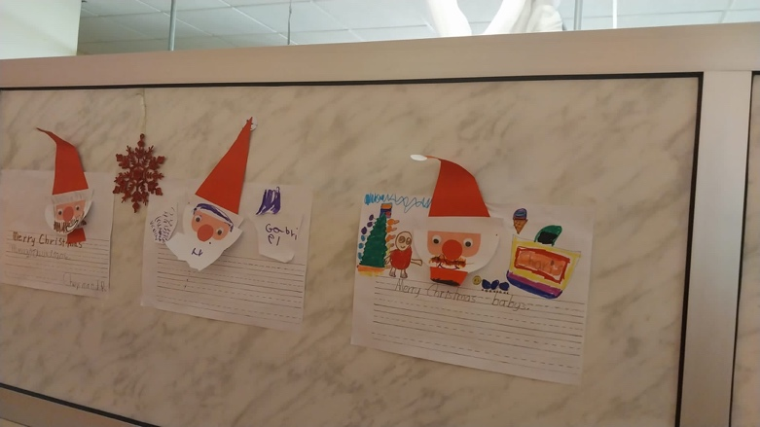
In Partnership with ELWA Hospital Paediatric department, Monrovia
Introduction
November 2023 was the busiest month at ELWA hospital for inpatient paediatric admissions. The hospital remains a beacon of hope, holding out the love of Jesus for the many children who have suffered with malnutrition, as well as for the many newborns who come through the service unable to access care in other locations. The number of children far overwhelms the current capacity of physicians and we are thankful to God for the sacrifice of FNP Louise Omdahl, Dr Korha and RN Christy Lewis who maintain the program under very challenging circumstances while Dr Gloria and Dr Bryant will return in 2024.
The program remains under significant pressure and we welcome any interested partners. In order to make a Christmas donation please visit the SIM websites:
US: https://www.simusa.org/give/: Type in “sustaining God’s Children” and follow the steps.
UK: https://sim.co.uk/support/donate/donate-by-card/ Select “to help a particular project/ministry” and write “sustaining God’s children Liberia”.
Further information is available at www.ELWAchildren.com

Clinical Activities
There were a total of 394 paediatric admissions to the hospital which is a further increase on previous months and remains beyond what would normally be expected of the team on the ground. Of these, 271 were treated in the emergency room, mostly with far shorter admission times. Many of these children are treated in the new areas in the paediatric emergency room. The mortality rate was 5.3%, which remains low for the subregion, particularly given how unwell the children who present to the hospital are.
In the under 5 clinic, there were 1654 consultations, 691 of which were new patients through the hospital. The children treated through the clinic remain in need of early and high quality intervention to prevent deterioration, and ensuring an effective triage remains an ongoing challenge. The staff continue to serve with a high level of dedication.
Special Malnutrition Update
The number of children admitted to the inpatient feeding units was 76, although there were 32 other children admitted into the emergency room, meaning that a record 108 children with malnutrition severe enough to need admission to hospital overnight came through ELWA. This high number took place due to the many children presenting after the transportation problems following the election. The intervention of LIVE2540 and EMA USA in supplying all the nutritional products during the first few years of the program’s life has been key in reaching these numbers.
The outpatient feeding program has stayed busy throughout the month, with 67 males and 86 females (153 total) starting on plumpynut throughout the month. The program was able to celebrate the release of 49 children who had gained sufficient weight to reach discharge criteria. At the end of the month 125 children were receiving plumpynut regularly. The main challenge facing the program remains the high defaulter rate, with 50 children lost to follow up during November. This number was unusually high this month as a result of the difficulties in transportation during the election, and efforts to encourage children to return to the program continue to be implemented.
Blessing is an 8-month-old girl who was brought to ELWA Hospital near the end of November. Her mother noticed that her young daughter’s ribs were protruding, her body was looking wasted and that she was not urinating well. She was in deep distress and her Mum was told by her mother-in-law that ELWA Hospital saw children. The hospital was not too far. She decided to come.
Upon arrival, she was thankful to find out that the care would be free! This is a unique feature of the ELWA hospital malnutrition program in Liberia. Little Blessing was only 4.2 kg at 8 months old and met the criteria for Severe Acute Malnutrition. She had a temperature of 39 celsius, seemed very low in energy and was slightly dehydrated.
The team got to work right away implementing the standard WHO protocols that are in place. Blessing was moved to the inpatient feeding unit on the paediatric ward where skilled malnutrition nurses implemented doctor’s orders and began to give her specialized milks to help facilitate healing and weight gain.
Blessing tolerated the milks well from the get go and remarkably there was a quick response with good weight gain throughout. The combination of antibiotics, quick malaria response and thorough monitoring of the milk intake led to a huge improvement and she was soon able to go home. Seeing our whole team work together, with the nurses thoroughly monitoring the signs of deterioration and giving medication, the early ward rounding from the doctors and the enthusiasm of Blessing’s mother remains a tremendous inspiration.
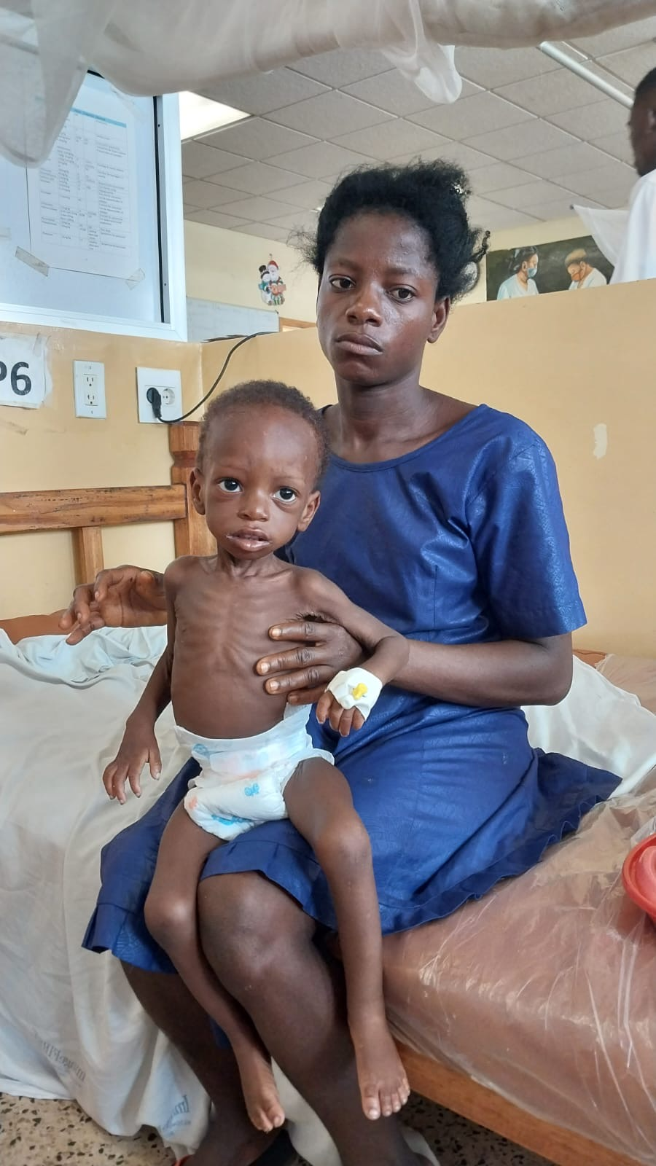
Patient Story
Baby Clarice was born on November 4th to a young mother. This was mom's first child, and she was excited for this new adventure. But Clarice’ mother has a low income and chose to give birth at home where family members helped her. She had no antenatal care. Clarice was born crying according to her mother, however after day 3, she was unable to suckle, jerking, febrile and crying all the time. Something was clearly wrong.
Her mother brought Clarice to ELWA Hospital ER, where she was initially assessed and treated by the team supported by CRWRF hoping to get some help. Her oxygen levels were 88% upon arrival and she had a fever. The team got to work. It did not take long to diagnose Clarice with neonatal tetanus—a disease that has largely been eliminated in the Western world due to vaccinations. Unfortunately, it is a common concern for those unable to deliver in a sterile setting and for those who have not been educated on the dangers of this deadly bacteria.
Clarice was brought to the paediatric ward and placed in a dark, quiet room to help minimize the easily triggered spasms caused by this horrific disease. After just 2 weeks Clarice began doing well. She came off most of her medications and the spasms began educing and becoming more controlled. She was soon able to tolerate her mother’s breast milk via a nasogastric tube, and recently even started to suck from a bottle.
Clarice and her mother defied the odds as survivors of tetanus are few and far between. The baby and mother have gone home and have great hope for the future. We are also thankful that her mother has been able to maintain her breast milk supply through all the challenges.
We are thankful for nurses that care, skilled providers and a large team of donors that stands behind helping infants like Clarice to survive against all odds! We continue to cry out to God for help for many of these little ones.
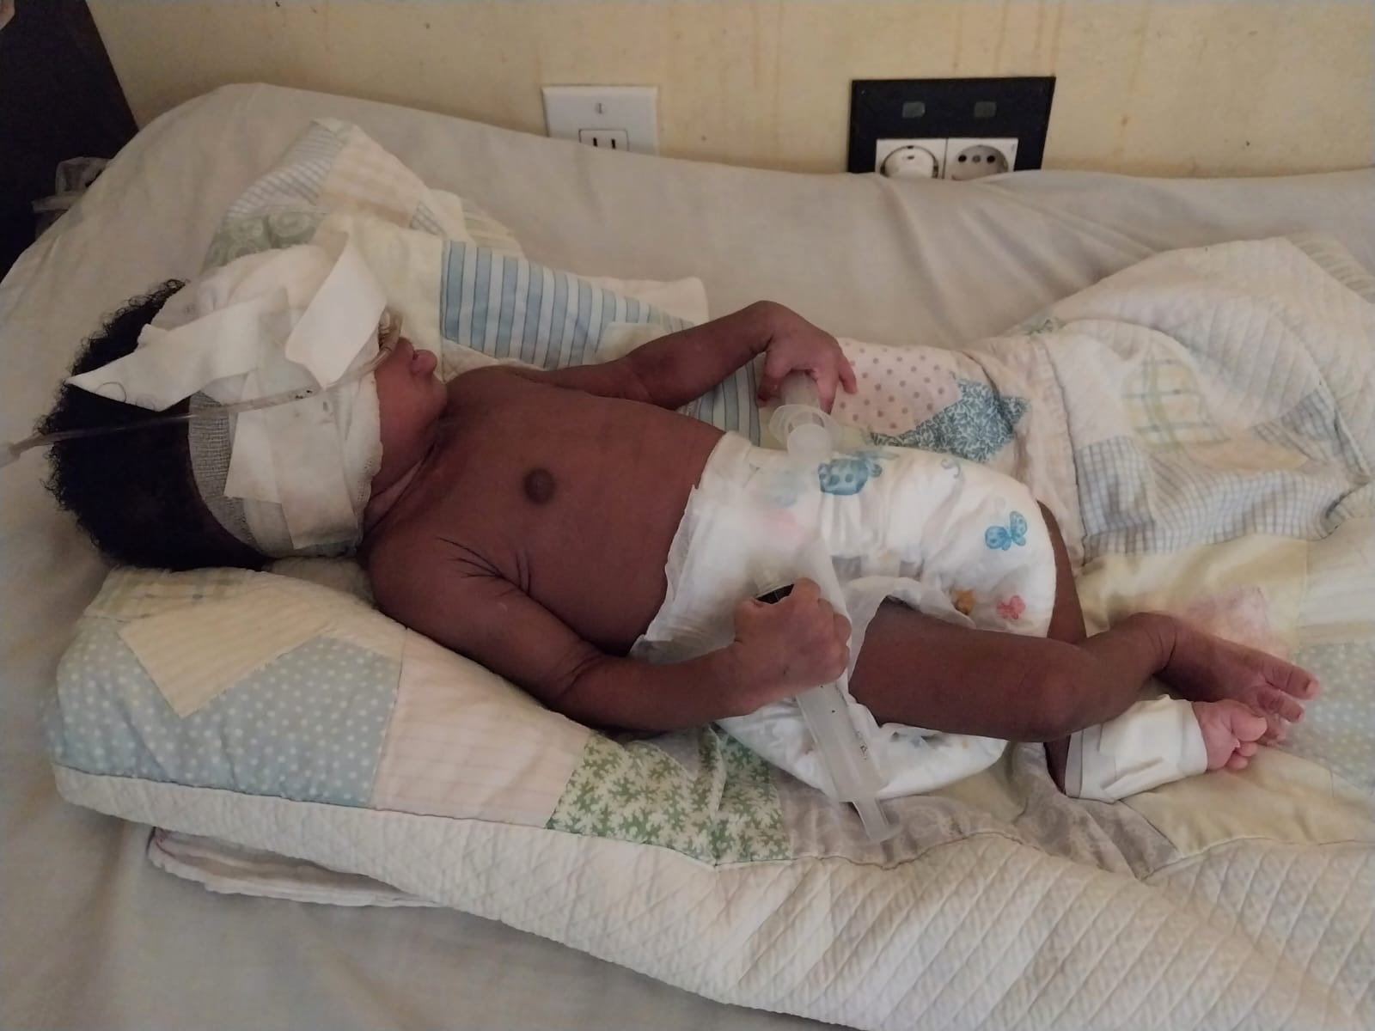
Educational Activities
The focus of educational activities during November was on training incoming staff members, with the British PA Guy Branson becoming fully accredited by the hospital as an ETAT plus mentor. He has since been able to mentor the PAs in the emergency room, ensuring that they are able to improve their skills in real time. Similarly there have been many teachable moments as staff members have seen improved outcomes as a result of the ETAT plus principles being applied to real life. Staff members involved in blood training:
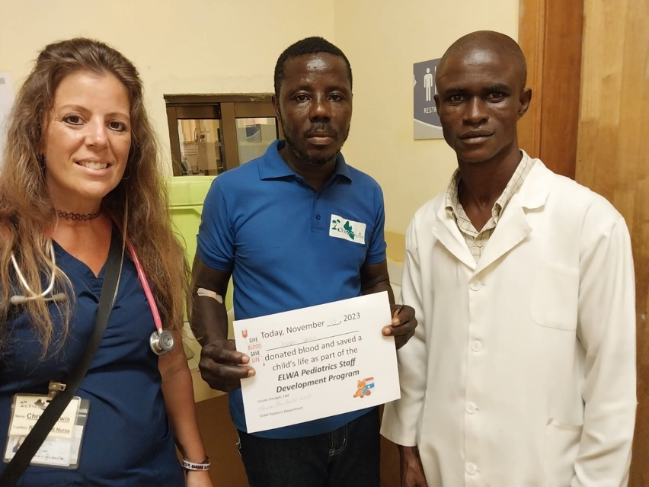
Future Goals
- Consolidation of previous learning for PAs and nurses during early 2024 through ongoing mentoring.
- Follow-up ETAT plus training course to be carried out at ELWA hospital where new staff in the ER will be fully trained during Spring 2024.
- Further ETAT plus workshops planned for throughout 2024 in Gbarpolu county, Buchanan and in collaboration with Medecins Sans Frontiers (MSF).
- Opening of second nutrition centre in Bong County, target date Spring 2024.
- Ongoing partnership with Ministry of Health to train and mentor interns and other doctors coming through the paediatric ward, set to restart January 2024.
Dr Michael Bryant MB BCh MRCP MRCGP DCH DTM&H
ELWA Hospital paediatric clinical lead
West Africa clinical lead, Swansea Bay Health Charity Africa Links programme

