October 2023 Report for Serving In Mission
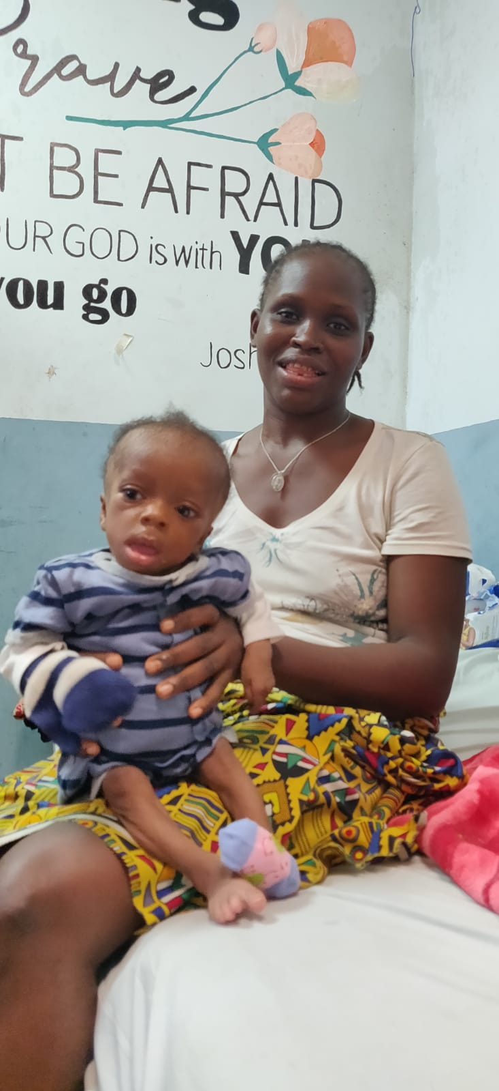
In Partnership with ELWA Hospital Paediatric department, Monrovia
Introduction
October 2023 remained a hectic month for the ELWA hospital paediatric department. Large numbers of children were treated at a high standard, and the malnutrition program numbers increased again reflecting the ongoing need around the country. While we put our trust each day in God we are thankful to be entrusted with the care of these vulnerable children. Many children presented in extremis including toddlers suffering with seizures and newborns who had initially been resuscitated in very basic nearby facilities. Thanks to the dedicated work of the team and God’s faithfulness, survival outcomes remained good and there were many mentoring opportunities to follow up on the ETAT plus training carried out the ETAT plus training carried out last month.
Clinical Activities
There were a total of 317 paediatric admissions to the hospital which is the highest on record, of which 90 were children suffering from severe acute malnutrition. Of these, 206 were treated in the emergency room, mostly with far shorter admission times. There was a very high number of extremely unwell children presenting through the hospital with hypoglycaemic attacks and seizures.
In the under 5 clinic, there were 2155 consultations, 1445 of which were new patients through the hospital. These children are treated earlier in order to avoid deterioration, and by recognising and admitting unwell children earlier many lives are saved. Throughout October there has been ongoing mentoring of the physician assistants carried out by a new physician assistant from the UK in addition to the ongoing training provided by the team based long term on the ground. The clinic now has a dedicated PA for the children with malnutrition.
Team farewell for one of the intern doctors:
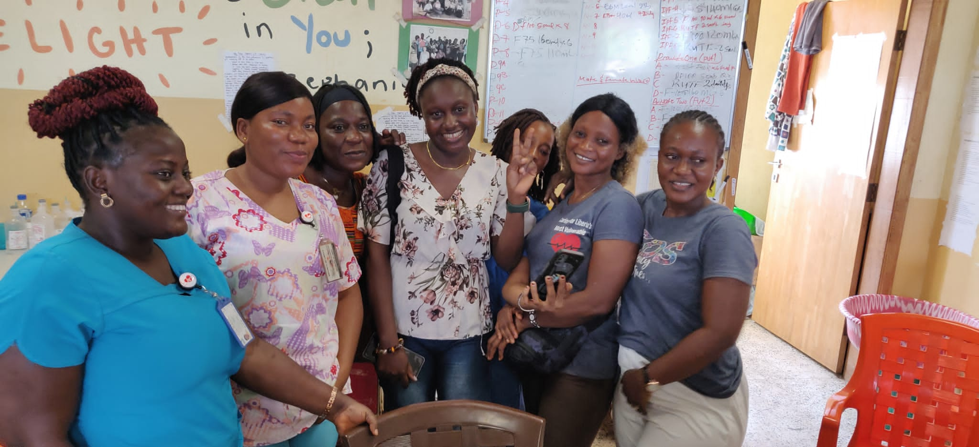
Special Malnutrition Update
The number of children admitted to the inpatient feeding units was 90. Many of these children were extremely malnourished, many with kwashiorkor-type malnutrition. We are thankful for God’s provision of groups such as Samaritan’s Purse and LIVE2540 for supplying the F75 and F100 milks needed, and now also supporting many of the essential operating costs such as the electricity needed to operate oxygen concentrators and food for the families. This, combined with the support provided by donors through SIM for the staff caring children in the emergency room, has kept the program from closing. Many of the children presenting through the emergency room are in conditions of near starvation as the lack of availability of other primary healthcare facilities has caused many children to deteriorate quickly.
The outpatient feeding program refilled throughout the month, with 139 new admissions to the OTP throughout the month. There were 54 children who celebrated being discharged as cured leaving 80 children being treated for malnutrition on an outpatient basis. As the election has continued to take place and run into a second round it remains challenging for children to reach the hospital for follow-up visits.
The malnutrition program continues to treat some of the most unwell children such as Baby Joe, who had been sick for a long time, steadily deteriorating at home. He had started to get more swollen up as his mother had run out of food to give him and was getting more breathless every day. To make things worse, he started to suffer from diarrhoea with very little control of his bowels. As with many thousands of children, he had been taken to a collection of pharmacies and clinics, all of which either had no trained staff or no medication.
His mother brought him to the hospital in desperation, thankful that he was seen very quickly in the emergency room. The staff rapidly took in the swelling of both of his legs, the comatose state, the inability to drink and the fast breathing. Within minutes of arriving the senior nurse had started oxygen and recognising that feeding was not going to happen easily had inserted a nasogastric tube to start some F75.
Despite all these prompt responses there was still one problem. Baby Joe had no visible veins, with fluid blanketing all his limbs, so finding a way to give antibiotics was going to be a battle. His blood sugar reading came back at 2.1. Without some urgent intervention, Baby Joe was almost certainly going to die. The team kept trying and thanks to the ETAT plus training the previous month there were several members of the team who were able to insert an intra-osseous needle then rapidly start some dextrose and antibiotics.
Almost immediately the lights came on inside Baby Joe! The eery silence over his face melted away and he began crying, babbling some toddler words about milk and mummy and going home. His mother’s sobs turned to smiles as he began holding her again, smiling as she saw the dramatic change. By the next day he was drinking plenty and even giggling a little as more milk came every couple of hours. His legs came alive, robotic at first but soon remembering their old energy and beginning to potter around the ward, then amazingly, home and well!
Incredibly, a simple yet counter-intuitive intervention such as a needle into a bone changed the course of a child’s life. Having the combination of the right equipment, trained personnel and opportunities for care is key in saving the lives of the vulnerable children who come through.
Plumpynut supplies received and ready to take care of vulnerable children:
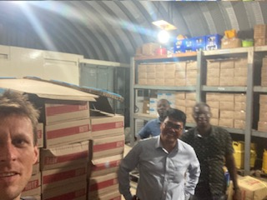
Patient Story
Another child helped by the hospital was a neonate born in a facility with very limited oxygen and a smaller supply of medication. She was rushed into the hospital after seizing at home for several hours. She had been unable to feed for some days and appeared very jaundiced. ELWA remains a safe-haven, God’s provision for the many newborns who come in desperate need of care.
Thanks to rapid intervention from the team she was able to be started on the right anticonvulsants and antibiotics within 30 minutes of arriving! Baby Tetee was moved upstairs to the newborn care space very quickly and started on phototherapy so that the yellowness in her eyes was able to start to rapidly go down.
The more complex treatment began here. She was started on the right fluid to keep her from getting dehydrated or seizing again, and as she started to come around feeding started initially through a nasogastric tube and then the welcome suckling began. Getting just the right fluid for a baby so that they are able to stay hydrated but at the same time able to avoid being overloaded is extremely tricky and involves a fine balance. However in the newborn care space Tetee and family found strength in the team all around her with nurses well-familiar with feeding helping her through every decision. Other mothers of babies who have been in hospital for some time were able to help her understand what was happening each day and encourage her that there was still hope.
Amazingly, after 72 hours Tetee opened her eyes and was able to cry for the first time! The rapid intervention and dedicated care on the newborn care space means that she has a bright future ahead with strong support. For many babies it is the attention to detail which has changed the course of their lives and transformed family journeys. Baby Tetee:
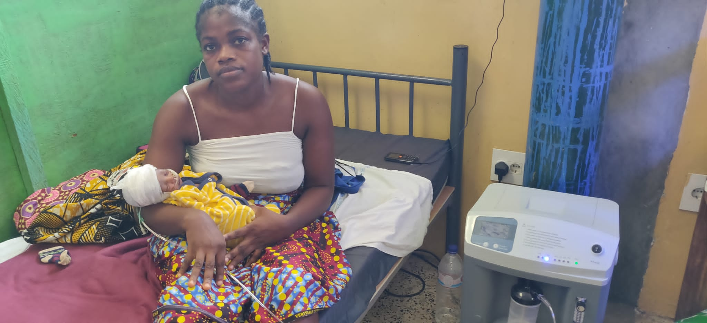
Educational Activities
ETAT plus follow up training took place early in October with a group of physician assistants and nurses working in the emergency room. This was carried out over a period of several afternoons and followed up with direct mentoring in the triage area of the ER. Topics covered included:
- Severe Acute Malnutrition.
- Use of order sets in guiding patient care.
- Fluid management in dehydration and shock.
- Newborn emergency care.
This training involves a more structured approach with follow up given for topics discussed earlier this year and the ongoing presence of international mentors to support the staff caring for children in the ER.
During October, the project team were also able to present a significant quality improvement update in relation to the outpatient feeding program at the Royal College of General Practice international conference in Glasgow, UK. This presentation was the winner in the international health category and provided helpful professional exposure for the work at ELWA hospital:
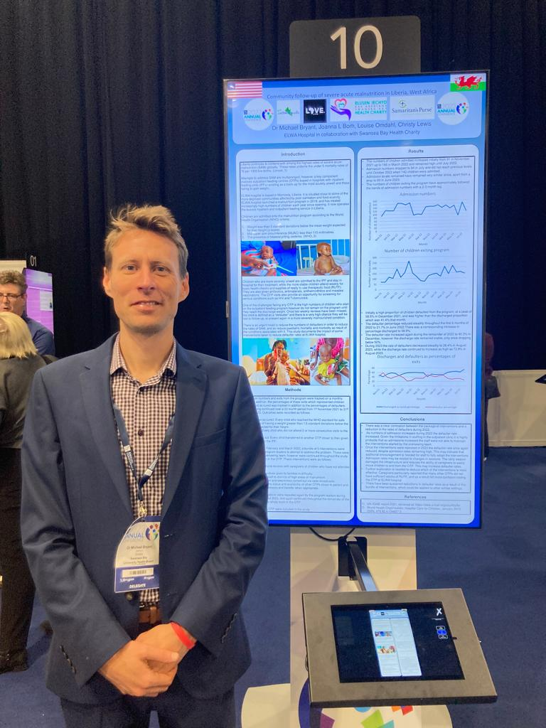
Future Goals
- Consolidation of previous learning for PAs and nurses during November/December 2023 through ongoing mentoring.
- Follow-up ETAT plus training course to be carried out at ELWA hospital where new staff in the ER will be fully trained during early 2024.
- Further ETAT plus workshops planned for throughout 2024 in Gbarpolu county, Buchanan and in collaboration with Medecins Sans Frontiers (MSF).
- Opening of second nutrition centre in Bong County, target date Spring 2024.
- Ongoing partnership with Ministry of Health to train and mentor interns and other doctors coming through the paediatric ward, set to restart January 2024.
Acknowledgements
The writers acknowledge the support of LIVE2540 in providing the nutritional products and other forms of support, in addition to Swansea Bay’s support for the funding to continue to supply the paediatric ward, under 5 clinic and paediatric emergency department. Without this funding the work simply would not be possible. The work would also be impossible without the continued support of Win Griffiths OBE and the essential partnerships with EMAUSA, mylocaldoc Australia, CRWRF and Samaritan’s Purse.
We are privileged to have the support of many individuals and churches around the world who are deeply invested in the work of ELWA hospital paediatric department.
Dr Michael Bryant MB BCh MRCP MRCGP DCH DTM&H
ELWA Hospital paediatric clinical lead
West Africa clinical lead, Swansea Bay Health Charity Africa Links programme

