LESSONS FROM DAVID WEEK 5 19 / 23 NOVEMBER DAVID’S FRIENDSHIP
1 Samuel 18. 1-4; also 20; 23. 15-18; 2 Samuel 1. 11-12, 17-27; also 2 Samuel 23. 13-17
David and Jonathan - a legendary friendship
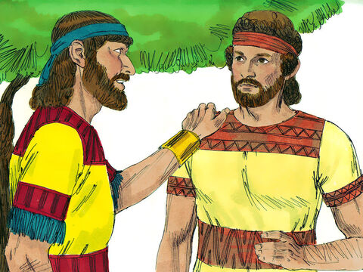
Lectio: The passages in 1 Samuel tell the story of the friendship between King Saul’s son Jonathan and David, who is being hunted by Saul. The last chapter of 1 Samuel tells how Jonathan is killed in battle against the Philistines and Saul is so badly wounded he falls on his sword to avoid being captured. 2 Samuel chapter 1 contains David’s eloquent and heartfelt lament for both of them.
Explore:
- How important to you are your friendships? From your own experience, how does a strong friendship begin and how is it sustained. Search out the characteristics of the friendship in this story, and the ways in which it’s put to the test. Look at 1 Samuel 20, and 23. 15-18 Can you relate to any of its features? Should the story be called ‘Jonathan and David’?
- David obviously also inspired devotion in his men – read the story in 2 Samuel 23. 13-17
- David and Jonathan made a solemn promise to each other in the presence of God, and honoured it. How does a shared faith enrich a friendship? Does that mean friendships with non-Christians are less valuable?
- Look at Jesus’ words in John 15. 12-14. Do you think of Jesus as your friend?
Worship:
I’ve found a Friend, oh, such a Friend!
He loved me ere I knew Him;
He drew me with the cords of love,
And thus He bound me to Him.
And round my heart still closely twine
Those ties which naught can sever,
For I am His, and He is mine,
Forever and forever.

I’ve found a Friend, oh, such a Friend!
He bled, He died to save me;
And not alone the gift of life,
But His own self He gave me.
Naught that I have my own I call,
I hold it for the Giver;
My heart, my strength, my life, my all,
Are His, and His forever.

I’ve found a Friend, oh, such a Friend!
So kind, and true, and tender,
So wise a Counsellor and Guide,
So mighty a Defender!
From Him who loves me now so well,
What power my soul can sever?
Shall life or death, or earth or hell?
No! I am His forever.

