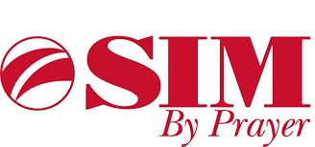
September 2023 Report for SIM
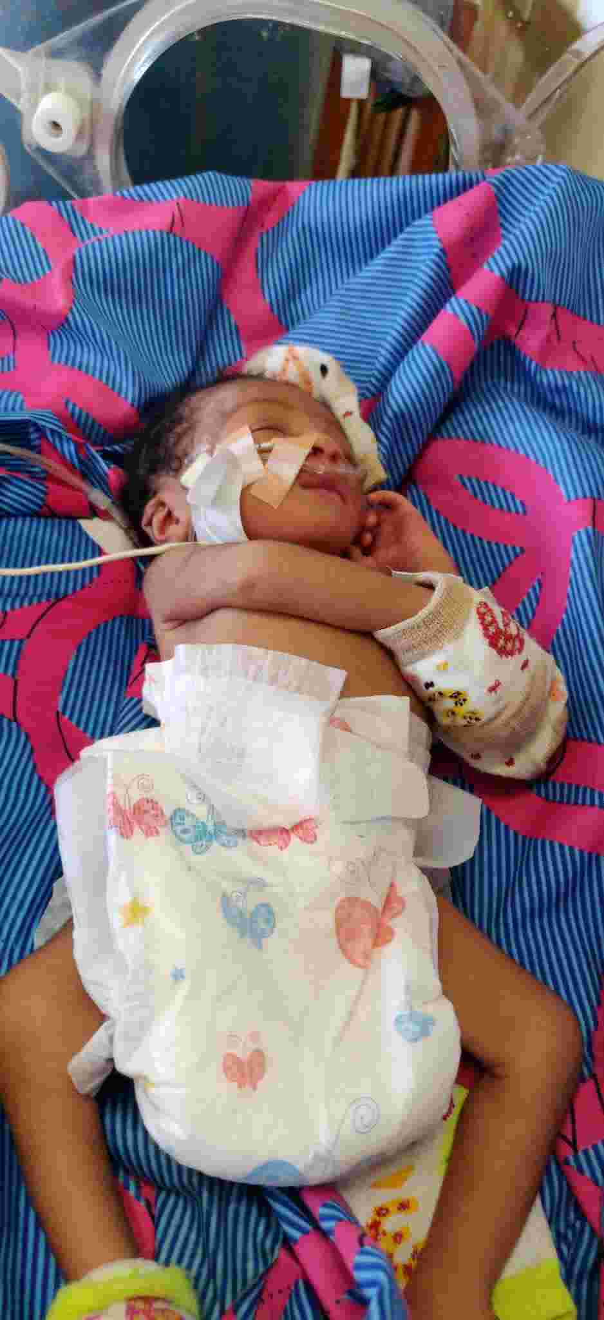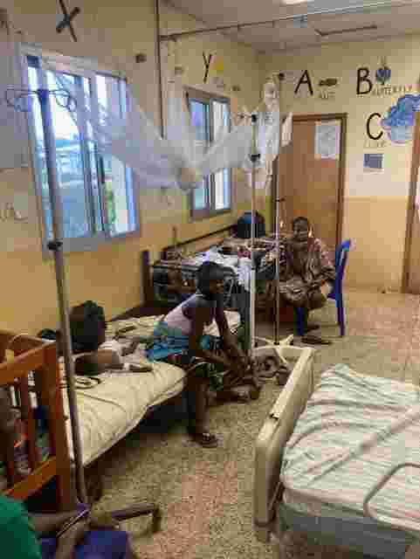
In Partnership with ELWA Hospital Paediatric department, Monrovia
Introduction
September 2023 was a very busy month for ELWA paediatric department. In addition to extremely high numbers of children presenting through the department, remarkable progress was made moving the ETAT plus training forwards. One of the most effective training weeks to date was carried out in Tapeta, Nimba county. This has continued to strengthen ELWA hospital and our partners’ role within Liberia as leaders in emergency paediatric care. We are thankful that God continues to open doors for us to carry out coherent outreach activities throughout the country and for the many SIM members and associates who give themselves to this work, as well as the churches and individuals who give via SIM.
Clinical Activities
There were a total of 291 paediatric admissions to the hospital, of which 75 were children suffering from severe acute malnutrition. Of these, 213 were treated in the emergency room, mostly with far shorter admission times. The majority of children were treated for conditions such as pneumonia, diarrhoeal illnesses and malaria, while a very high number of newborns continue to present through the emergency room. The hospital remains a refuge for sick babies who are born in unsafe environments. It is hoped that in time an affordable maternal health system will be established.
In the under 5 clinic, there were 1864 consultations, 854 of which were new patients through the hospital. These children are treated earlier in order to avoid deterioration, and by recognising and admitting unwell children earlier many lives are saved. Several discussions were held during September to address the challenges with triaging overwhelming numbers of children and rationalise prescribing. The department has recently recruited a physician assistant, Guy Branson, sent via SIM UK to strengthen the systems for triage in this area.
Special Malnutrition Update
The number of children admitted to the inpatient feeding units was 75. Many of these children were extremely malnourished, many with kwashiorkor-type malnutrition. We are thankful for the faithfulness of Samaritan’s Purse and LIVE2540 in particular for supplying the F75 and F100 milks needed. Many of these children present extremely unwell at risk of hypoglycaemic attacks and with respiratory distress. Much careful rounding is needed not only daily but with dedicated reviews throughout the day.
The inpatient and outpatient feeding remained very full throughout the month. The outpatient feeding program treated 46 male and 45 new female children. There were 63 children who celebrated being discharged as cured leaving 47 children being treated for malnutrition on an outpatient basis. The slightly lower number was as a result of reduced presentation of children due to the election.
The malnutrition program continues to care well for the most unwell children coming through the hospital while also addressing their nutritional needs. One baby with a very complex story was Desire, a little 18 month old baby who came in via the additional beds added into the emergency room. She was came in breathing fast, and alarmingly thin, her tiny arms waving for help. Soon she was started on oxygen and quickly recognised as suffering from malnutrition. She was able to start on the F75 milk, and all seemed to be going well.
Suddenly on day 3, Desire starting seizing. In a panic Mum worried that everything was lost and there would be no way for her to survive. The nurses supported by Canada Reformed World Relief Fund (CRWRF) gathered around, nervous but filled with the skillset recently given to them in the ETAT plus follow-up training. In a display of calm compassion beautifully at odds with the chaos around, the nurses took Mum aside and prayed with her while the physician assistant team started serving anticonvulsants. Desire’s flailing arms remarkably began to settle, her breathing settling back into a healthy rhythm as sleep overtook her. Amazingly, she did not convulse again until waking up to drink the milk, which with a few days she was drinking thirstily.
After just 10 days, Desire was ready to get home. As she got up to go, she was said in astonishment, “ELWA can really care for children, I didn’t believe a child in that condition could ever make it. Thank you so much!” In amongst all the hard work and chaos it is hugely rewarding to watch children go from having no hope to returning home smiling.
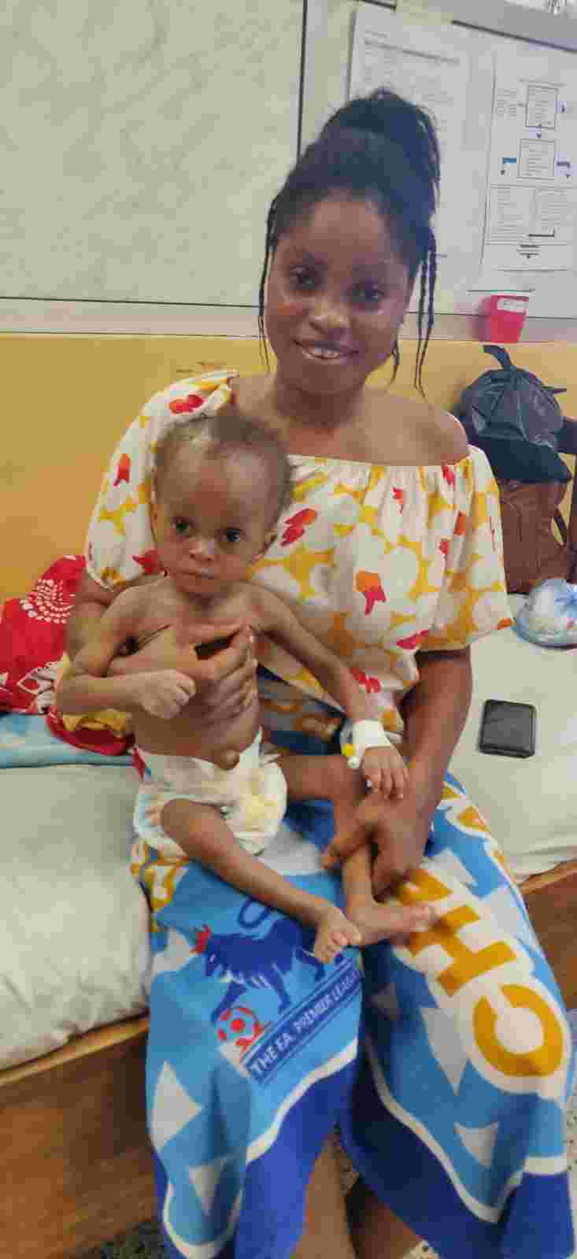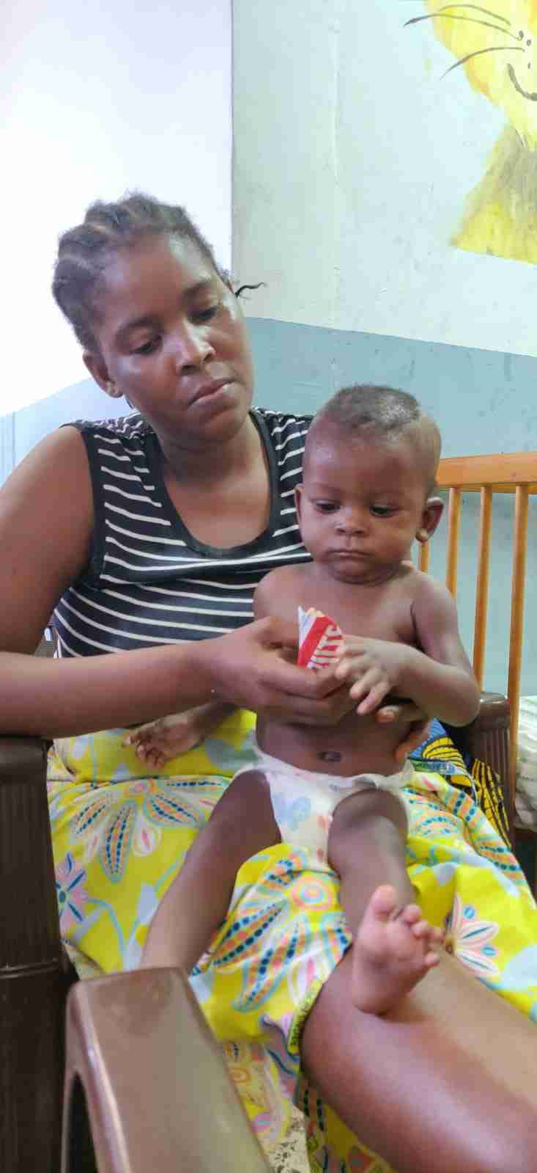
Patient Story:
Teddy is a little 3 month old boy, born in one of the poorer communities in Monrovia. His Mum noticed him breathing a little faster one morning, and decided to try to get some medicine. Going from store to store she eventually found some amoxicillin and started feeding it to Teddy. Despite this, he started breathing faster. His Mum had heard there was a hospital which might be able to help with sick children called ELWA. Seeing his breathing worsening day by day, she pulled him over to ELWA in a panic.
As soon as he came in the team in the ER swung into action, well-trained and ready to care. Recognising the danger signs quickly, he was placed straight onto oxygen while other energetic nurses found IV access. Pretty soon it was obvious that the oxygen alone wasn’t working. Little Teddy was getting tired, his breaths starting to get fainter and weaker. Remarkably quickly, one of the newly trained nurses in the triage area took the initiative and hooked him up to the bubble-CPAP, all before the doctor had arrived! The transformation was almost immediate as his rapid breathing settled down to leave him far more settled and relaxed. Another great teaching opportunity came up as the nursing and PA team were able to work through the fluid management.
Somehow, Teddy kept improving, his tiny alveoli re-opening to the air and his cry waking the ELWA morning. His mother’s stress began melting into joy, and she began encouraging all the other children’s families as they came through. The team kept plugging away, turning the CPAP up and down as he needed it. Despite the sudden setback of having lost IV access one morning, the team were able to calculate nasogastric feeds very well.
Amazingly, a week into the treatment, Teddy was able to come off the CPAP! Remarkably, his breathing and suckling had learned how to co-ordinate themselves, and he was back to enjoying feeding incessantly close to his very grateful mother! To take a child from distress, panic and rapid breathing to being whole and well is a huge privilege, and being able to bring the whole medical team on this journey represents a great step forward for the hospital. This represented a tremendous answer to prayer.
Educational Activities
ETAT plus training carried out in Jackson F Doe hospital, Tapeta, Nimba County. There were 51 participants. Topics covered included:
- Severe Acute Malnutrition.
- Triage
- Airway management
- Breathing
- Circulation and dehydration
- Coma and Convulsions
- Newborn Care
This training involved a more sustainable approach than previously. In collaboration with the ministry of health, a previous ETAT plus facilitator has been assigned to the hospital on a permanent basis. This is more likely to embed the skills and knowledge training into practice on a more long term basis. Much of the training included discipleship activities exploring practicing medicine God’s way.
The pass rate for the training was 80%. The practical assessments carried out each day were significantly refined compared to the previous ETAT plus short course in order to improve standardisation and ensure that the participants were truly able to manage fluid calculations and newborn resuscitation in particular. ETAT trainers group in action:
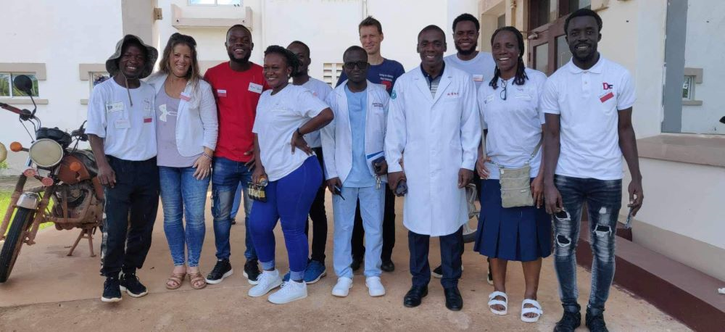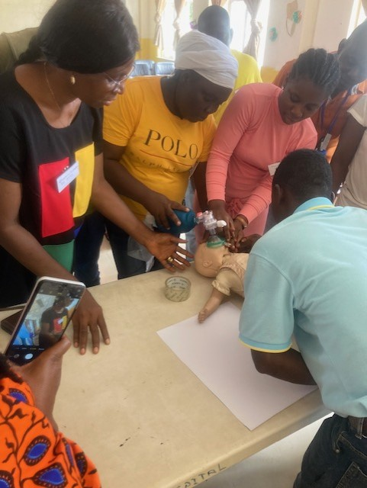
Future Goals
- Consolidation of previous learning for PAs and nurses during October 2023.
- Follow-up ETAT plus training course to be carried out at ELWA hospital where new staff in the ER will be fully trained during December 2023.
- Further ETAT plus workshops planned for early 2024 in Gbarpolu county, Buchanan and in collaboration with Medecins Sans Frontiers (MSF).
- Opening of second nutrition centre in Bong County, target date Spring 2024.
- Ongoing partnership with Ministry of Health to train and mentor interns and other doctors coming through the paediatric ward.
- Detailed evaluation of practice of PAs and doctors to be carried out by project lead in September.
Acknowledgements
The writers acknowledge the support of many faithful donors who give via SIM in providing support for staff, Samaritan’s Purse and LIVE2540 in providing the nutritional products and other assistance, in addition to Swansea Bay’s support for the funding to continue to supply the paediatric ward, under 5 clinic and paediatric emergency department. Without this funding the work simply would not be possible. The work would also be impossible without the essential partnerships with mylocaldoc Australia, EMAUSA and CRWRF.
We are privileged to have the support of many individuals and churches around the world who are deeply invested in the work of ELWA hospital paediatric department.
Dr Michael Bryant MB BCh MRCP MRCGP DCH DTM&H
ELWA Hospital paediatric clinical lead
West Africa clinical lead, Swansea Bay Health Charity Africa Links programme

