LESSONS FROM DAVID WEEK 3 5 / 9 NOVEMBER SAMUEL 24. 1-11
DAVID’S LOYALTY
The story so far (1 Samuel 18-23):
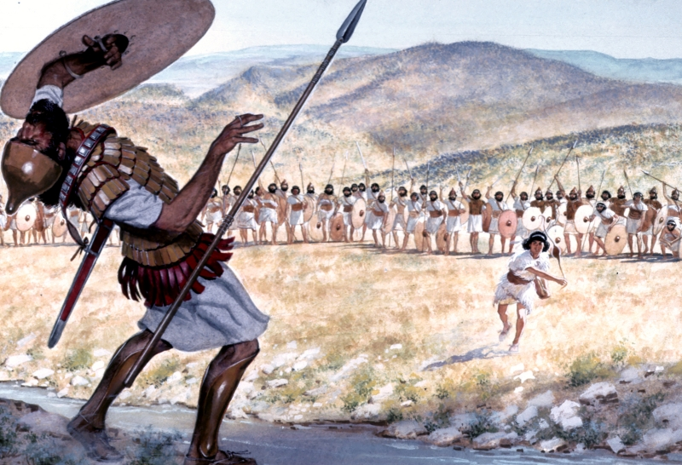
King Saul has become increasingly jealous of David’s success and popularity and has made a number of attempts on his life. A band of young men have gathered round David and they are living as outlaws in caves in a desert region. Saul has raised an army to hunt him down.

Lectio: Read the passage silently, and then aloud. Sense the drama, try to enter into David’s internal conflict.

Explore:

- Read 1 Samuel 18.12 and 23. 14-18. Why does Saul fear David? Is this fear justified? Jonathan, Saul’s son, and David have formed a very close friendship. Look at his role in giving David reassurance.
- Why doesn’t David do as his supporters suggest? Why does Saul’s anointing protect him, and what does this show of David’s understanding of and reverence for this concept?

- Do you agree with the title, ‘David’s loyalty’? To whom or what is he showing loyalty?

- Read on to the end of the chapter. Note Saul’s apparent change of heart. Then look at chapter 26, when history repeats itself, and Saul’s character again is contrasted with David’s.

- In chapter 24 verses 21-22, David swears an oath to Saul. See in 2 Samuel 9. 1-7 how loyally he keeps it, after Saul and Jonathan have been slain in battle.

- Psalm 24 is a Psalm of David. Verses 3-5 say:
Who may ascend into the hill of the Lord?
Or who may stand in His holy place?
He who has clean hands and a pure heart,
Who has not lifted up his soul to an idol,
Nor sworn deceitfully.
He shall receive blessing from the Lord,
And righteousness from the God of his salvation.

Did David practise what he preached?

Apply: What lessons from this story can you apply to the way you live your daily life, on your frontline?

Worship: Faithful One, so unchanging
https://www.youtube.com/watch?v=7PjSO5Ihl0M

