LESSONS FROM DAVID WEEK 2 29th OCTOBER / 2nd NOVEMBER
1 SAMUEL 17. 25-26, 32-51 DAVID’S FAITH
Historical background: The origins of the ancient Philistines, the greatest enemies of the Israelites, have puzzled scholars for decades, but recent DNA testing of skeletal remains has revealed that they came to the Middle East from southern Europe more than 3,000 years ago. Thanks to their depiction in the Old Testament, their name has become synonymous with crassness, ignorance and hostility to culture. But excavations in 2016 of the first ever Philistine cemetery, unearthed in the coastal city of Ashkelon, found bodies buried with jewellery and perfumed oil, which suggests these people were actually no ‘philistines’. Certainly the description of Goliath’s bronze armour suggests skilled workmanship.
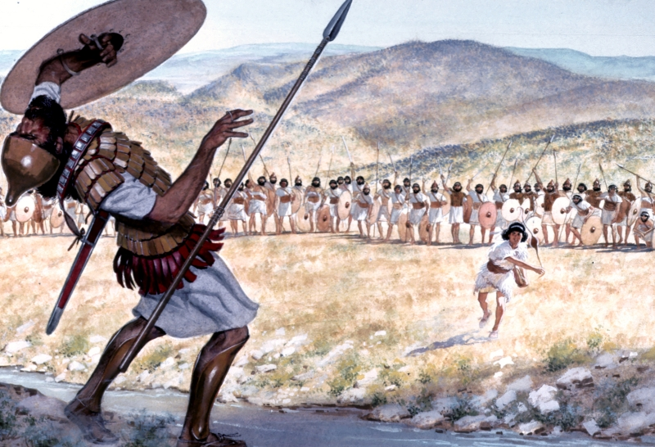
Lectio: This is one of the great stories of the Bible, so you may want to read from the beginning of the chapter, through to verse 51. Having a narrator and taking parts brings the drama alive. It also rewards a second, reflective silent reading.

Explore:
- Note how David as the youngest son still has a lesser status than his brothers. What might lie behind Eliab’s anger with David? (verses 17-22, 28-29)
- Look at the conversation in verses 25 and 26. Compare the terms in which the soldiers describe Goliath’s challenge, with how David sees it. Consider what he means by Israel’s disgrace, what adjective he uses for Goliath, and how he describes Israel’s army.

- What is the source of David’s confidence when he replies to Saul? (Verses 34-37) What response does this elicit from Saul?

- Enjoy the comedy of David trying to move in Saul’s armour (verses 38-39). Then read the confrontation with Goliath (verses 41-47). In meeting Goliath’s challenge to single combat, in whose name does David come? How will the outcome impact those watching, and who will get the glory? Although some words in Zechariah chapter 4 are spoken in a different context, they seem very apt: ‘Not by might nor by power, but by my Spirit,’ says the Lord Almighty. (verse 6) and ‘Who dares despise the day of small things?’(verse 10)

- Read Psalm 18. 24-33 The introduction says David sang this to the Lord after a later and greater deliverance, but bearing in mind last week’s study of David’s heart, this passage shows the spirit in which he stood up to Goliath.

Apply: What challenging situations may we encounter, where we need the faith David showed? Do you have a testimony to share? Are you in a daunting situation right now? Pray for one another. How will your response to a challenging situation impact non-believers?

Worship: Strength will rise as we wait upon the Lord (Chris Tomlin). https://www.youtube.com/watch?v=JSHRThrP1O0

