NEW SERIES LESSONS FROM DAVID WEEK 1 22nd/26th OCTOBER 1 SAMUEL 16. 1-13 DAVID’S HEART
Introduction: David (flourished c. 1000 BC), was a shepherd in his youth. The prophet Samuel anointed him as the king to succeed Saul, who had departed from obedience to God. His first exploit was slaying the Philistine giant Goliath. After a time living as an outlaw, pursued by Saul who wanted to kill him, he succeeded him and is remembered as the greatest king of Israel. He is also the human ancestor of Jesus (Matthew 1.6). Jesus, who was born in Bethlehem, the birthplace of David, is sometimes addressed as ‘Son of David’ (eg by blind Bartimaeus in Mark 10. 46-48, and on his entry into Jerusalem, Matthew 21.9). The life of David is told in the two books of Samuel. Many of the Psalms are attributed to him and he is sometimes described as ‘The sweet singer in Israel’. We will begin each study by reading some verses from a Psalm of David. Today read Psalm 139. 1-6
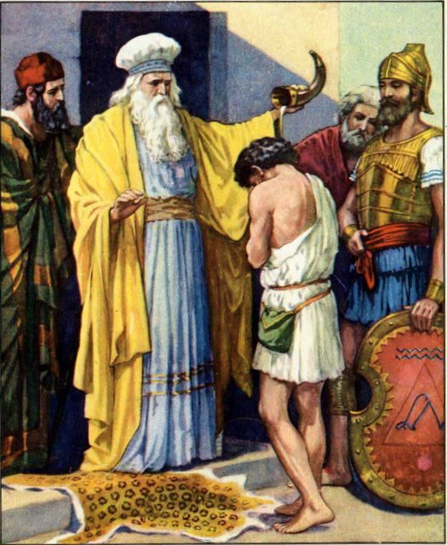

Lectio: First read 1 Samuel 13. 13-14, in which Samuel tells Saul why his kingdom will not endure.
Then read 1 Samuel 16. 1-13, with narrator plus readers for the Lord and Samuel (including his thoughts). Read it again, silently. Try to picture the scene.

Explore:
- The word ‘Heart’ (Hebrew lebab/leb, Gk. kardia) occurs over one thousand times in the Bible, making it the most common anthropological term in the Scripture. It denotes a person's centre for both physical and emotional-intellectual-moral activities. Another definition: ‘In the Bible the heart is considered the seat of life or strength. Hence, it means mind, soul, spirit, or one's entire emotional nature and understanding.’
- When an expert in the law asked Jesus, ‘Teacher, which is the greatest commandment in the Law?’ Jesus replied: ‘Love the Lord your God with all your heart and with all your soul and with all your mind. This is the first and greatest commandment.’
- Jeremiah 17.10 says ‘I, the LORD, search all hearts and examine secret motives. I give all people their due rewards, according to what their actions deserve.’
- In John 2.25 we read ‘No one needed to tell Jesus about human nature, for he knew what was in each person’s heart.’
- Look again at these words from 1 Samuel 13, spoken by the Prophet Samuel to King Saul: ‘The Lord has sought out a man after his own heart and appointed him ruler of his people, because you have not kept the Lord’s command.’ From this verse, what behaviour defines someone as being ‘after the Lord’s own heart’?
- Do you wonder what the Lord saw in young David? Psalm 23 might suggest that as a shepherd boy his imagination was already in tune with the Lord’s character, comparing the Lord’s care of him with his of the sheep. Because he was a faithful shepherd, he didn’t run away when predators approached the flock. In chapter 17 he tells Saul, ‘When a lion or a bear came and carried off a sheep from the flock, I went after it, struck it and rescued the sheep from its mouth. When it turned on me, I seized it by its hair, struck it and killed it.’ He also reveals his passion for the honour of the Lord’s name. (17. 45-46)
- We’ve already read in Psalm 139. 1-6 how aware David was of God’s knowledge of him. How do you feel about God knowing you this intimately? Read David’s prayer in verses 23-24, and make it your own.
- What crucially happened when Samuel anointed David? What do you understand by this? Look at Psalm 51. 11 to see how much this meant to him. What about us? See Ephesians 5. 15-20.

Worship: https://www.youtube.com/watch?v=b3WVpgeXU5Y ‘Lord you have my heart’ (Delirious)

