WEEK 6 15th/19th OCTOBER JOHN 21. 1-19 DO YOU LOVE ME?
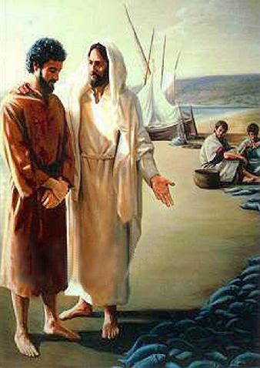
Ask yourself: Do I love Jesus? How? Why? How do I express this?

Lectio:
This reading begins with a fishing trip and continues with a miracle, an encounter with the risen Jesus and a picnic breakfast on the shore. It’s only after the meal that Jesus takes Peter aside and asks this momentous question. Read verses 1-14, taking parts; imagine the scene – sights, sounds, smells – and think yourself into the feelings and emotions of the participants. Share what you felt, before moving on to read and explore the conversation between Peter and Jesus, verses 15-19.

Explore:
- Peter has already seen Jesus twice if not three times since his resurrection and as far as we know, nothing has been said yet about Peter’s darkest hour, when he lost his bottle and in panic denied he knew him, not once but three times. So now, after the disciples have all shared breakfast with Jesus, the moment of reckoning arrives. It’s clear from verse 21 that Jesus has taken Peter aside and walked along the beach with him. How gracious, to avoid embarrassing him in front of the others! What different emotions will he be feeling? See Luke 22:54-62, but also his behaviour in the earlier part of this chapter. Will the miracle of the huge catch of fish have reminded him of what happened when he first met Jesus? See Luke 5. 1-11.
- What other, different questions might Peter have dreaded Jesus asking him? Has Jesus already forgiven him? (See Luke 22. 31-34) Why do you think Jesus asks this question? Compare what Jesus said about the woman who washed his feet with her tears, Luke 7.47.
- Why does Jesus ask this question three times? (See note at the end about the different Greek words for love used by Jesus and Peter.)
- Look more closely at the first question. ‘More than these’ could mean ‘more than these friends of yours’, or ‘more than your boats and nets and role as a fisherman’. Ask yourself what ‘more than these’ might mean if Jesus asked you this question, and how you would answer. There’s another possible interpretation: Peter might be remembering his boast (Matthew 26. 31-35). Has he been humbled? Do we ever consider ourselves ‘better Christians’ than others? Have we been humbled?
- What is Jesus the Good Shepherd calling him to do? And why is love a prerequisite? And what are the risks of loving like that? See verses 18-19, and compare John 10. 11-15.

Respond: Has this study affected your answer to the question at the beginning? Reflect in silence and/or share with each other and pray for one another. Read 1 John 4.19 Sing or listen to ‘When I survey the wondrous cross’, https://www.google.com/search?client=firefox-b-d&q=when+i+survey+the+wondrous+cross#fpstate=ive&vld=cid:7cefbf63,vid:s83MsV3kocI,st:0

Note: There is some discussion among Biblical scholars, about the significance of the words for ‘love’ which Jesus and Peter use.
When they had finished eating, Jesus said to Simon Peter, “Simon son of John, do you love (agape) me more than these?”
“Yes, Lord,” he said, “you know that I love (phileo) you.”
Jesus said, “Feed my lambs.”
Again Jesus said, “Simon son of John, do you love (agape) me?” TURN OVER
He answered, “Yes, Lord, you know that I love (phileo) you.” Jesus said, “Take care of my sheep.”
The third time he said to him, “Simon son of John, do you love (phileo) me?”
Peter was hurt because Jesus asked him the third time, “Do you love (phileo) me?” He said, “Lord, you know all things; you know that I love (phileo) you.”
Jesus said, “Feed my sheep”.

Some suggest that Peter was too ashamed to admit to the godly ‘agape’ love, while others maintain that agape is not a higher form of love than phileo and that they can be used interchangeably. In any case, Jesus and Peter were speaking in Aramaic. The word Peter used, translated into the Greek ‘phileo’, may have meant ‘adore’. Matthew Henry, in his historic commentary (1706), translates thus:
In the first two enquiries, the original word is Agapas me-Dost thou retain a kindness for me? In answer to which Peter uses another word, more emphatic, Philoµ se-I love thee dearly. In putting the question the last time, Christ uses that word: And dost thou indeed love me dearly?

