WEEK 3 17th/21ST SEPTEMBER HAS NO ONE CONDEMNED YOU? JOHN 8:1-11
You may find when you look up this passage, that your Bible version has a note saying that this story does not appear in some early manuscripts – the implication being that it’s not part of the original gospel record. However, there are indications that it was left out because the church fathers couldn’t stomach the idea of Jesus appearing to condone adultery, a sin which they regarded with the utmost severity. See some quotations to support this, in Footnotes, below.
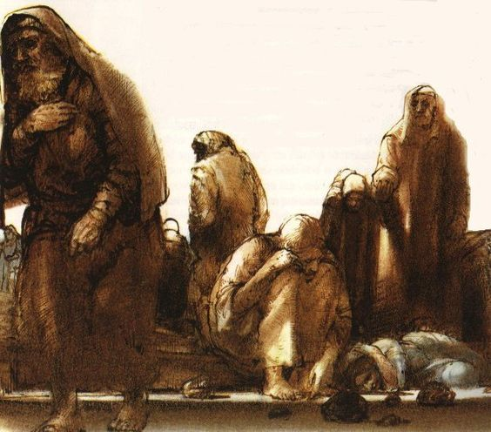
This is a very dramatic story. Read it once. Then in silence try to think yourself into the minds of the characters. For your second reading, could you act it out? At least, read it dramatically. How does it make you feel?
- Where does this incident take place? What are the motives of the teachers of the Law and Pharisees, in bringing this woman before Jesus? What is their frame of mind?
- How must the woman be feeling?
- There are many theories about what Jesus wrote on the ground. No one knows. Regardless of what he might have written, what do you think was the effect of Jesus doing this: [a] on the accusers? [b] on the woman?
- Jesus’ reply to the accusers had a dramatic effect. Why? How does Jesus pierce to the heart of humankind? One medieval suggestion about what Jesus wrote was ‘terra terram accusat’ (earth accuses earth). See Matthew 7. 3-5 What do you think about the significant detail in verse 9?
- How does Jesus’ reply reveal his deity? See John 2. 25, John 8.46, Mark 2.7
- Some church fathers thought Jesus was condoning adultery. Was he? Did the woman repent? Are sexual sins worse than other sins?
- Read John 12. 44-48, and reflect on why Jesus said he had come, especially in verse 47. Spend time in worship and thanksgiving.
How does this story apply to us?

- Is there anything for which we feel under condemnation? Accept the words of Jesus, spoken to the woman in this story. Listen to these words from Psalm 103 (verses 8-14): ‘The Lord is gracious and compassionate’ https://www.youtube.com/watch?v=7Xzk9qtlvuo Read Romans 8. 1-2
- Are we judgmental? Look again at Matthew 7, this time reading from verse 1. Pray for a non-judgmental heart.
Footnotes
In the Syriac Didascalia Apostolorum, composed in the mid-200s, the author… states that a bishop who does not receive a repentant person would be doing wrong – "for you do not obey our Saviour and our God, to do as He also did with her that had sinned, whom the elders set before Him….. He, the searcher of hearts, asked her, 'Have the elders condemned thee, my daughter?' She said to Him, 'No, Lord.' And He said unto her, 'Go your way; neither do I condemn thee.'”
According to Augustine (c. 400), it was a moralistic objection which was responsible for its omission in some of the New Testament manuscripts known to him. “Certain persons of little faith,” he wrote, “removed from their manuscripts the Lord’s act of forgiveness toward the adulteress, as if He who had said ‘sin no more’ had granted permission to sin.”

