WEEK 2 10TH/14TH SEPTEMBER WHO TOUCHED ME? MARK 5. 24-34
It’s a puzzling question, but one that changes a woman’s life. ‘Who touched me?’ A crazy thing to ask in the circumstances surely, but Jesus wants an answer. Is it because he doesn’t know who has touched him? Or does he want the woman to know that he knows and approves of what she has done? Does he want her to own her actions and understand that it is her faith, not some magical power, that has saved her?
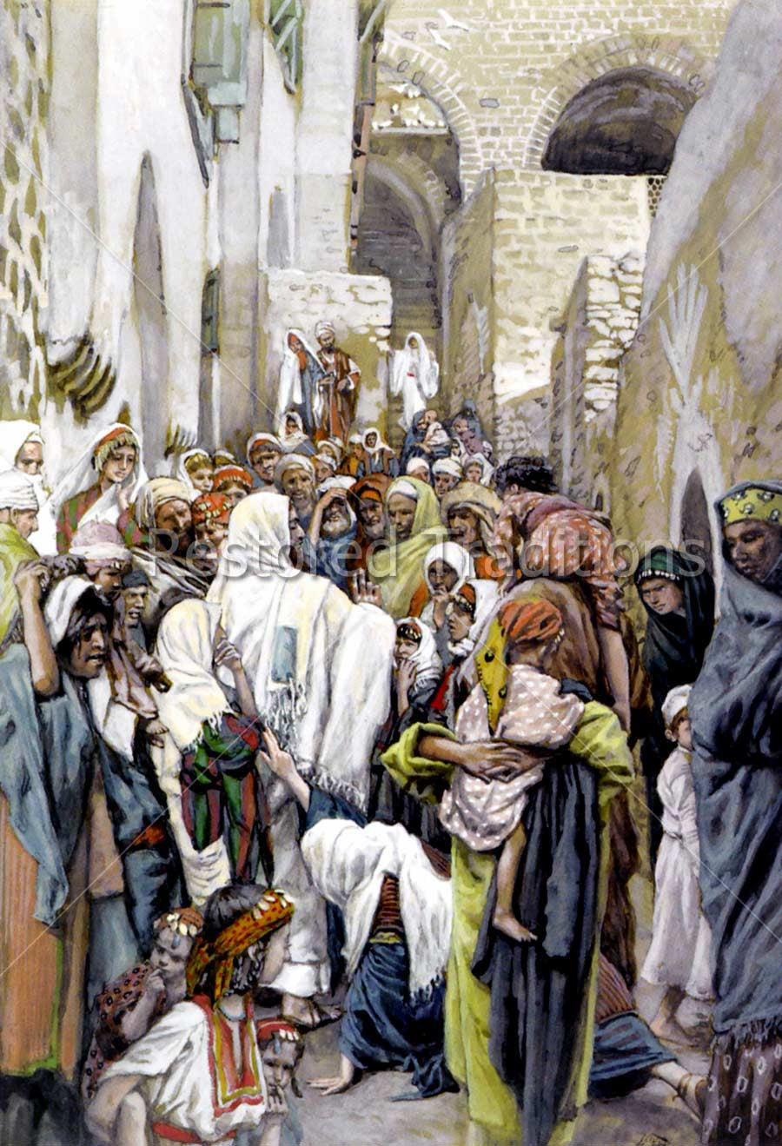
Paul Woolley, CEO, LICC
- What do you think? Read the passage carefully, twice, first aloud, then silently. What made Jesus ask ‘Who touched me?’ or ‘Who touched my clothes?’
- What were the responses of the disciples, and of the woman, to his question?
- What does this incident tell us about the cost to Jesus, of his healing miracles?
- Consider the plight of the woman. Notice how long her problems had lasted. Even today, with all our medical skill, a hysterectomy is the only treatment that helps many women with her condition. In her day, nothing was really effective. And her problem was compounded by the way she was viewed by Jewish law -- as ceremonially unclean. Women were normally considered unclean during their period. Anyone who knew about her illness would shun her. She couldn't go about in society and mingle in the marketplace with the other women, since a touch from her would make someone unclean. She couldn't attend ceremonial occasions, or synagogue worship. And so she resorts to secrecy.
- This story is embedded in another, the raising of Jairus’ twelve-year-old daughter. Read the whole story, Mark 5. 21-43. Jesus is on his way to the house of Jairus, a leader of the synagogue, whose daughter is dying. Surely he can’t spare the time to deal with this poor woman’s problems? In fact, isn’t the delay a calamity? See verse 35.
- There’s another thing - Jairus is a leader of the synagogue. How can Jesus continue to his house, once he’s been contaminated by this woman’s touch? Why does he disregard the strict Jewish law about contamination? You might like to see what he says in Mark 7. 1-8.
- Read the tender words of Jesus to the woman, and to the little girl. Reflect on his compassion and gentleness. What might he be saying to you?
Reach out and touch the Lord as he passes by; You’ll find he’s not too busy to hear your heart’s cry. He’s passing by this moment, your needs to supply; Reach out and touch the Lord as he passes by.
This is a very simple old chorus, but is it just what you need to hear? https://www.bing.com/videos/riverview/relatedvideo?q=reach+out+and+touch+the+lord+as+he+passes+by&mid=581241075489C1057605581241075489C1057605
Reflect, share and pray.
Is this a message you can share with someone else this week?

