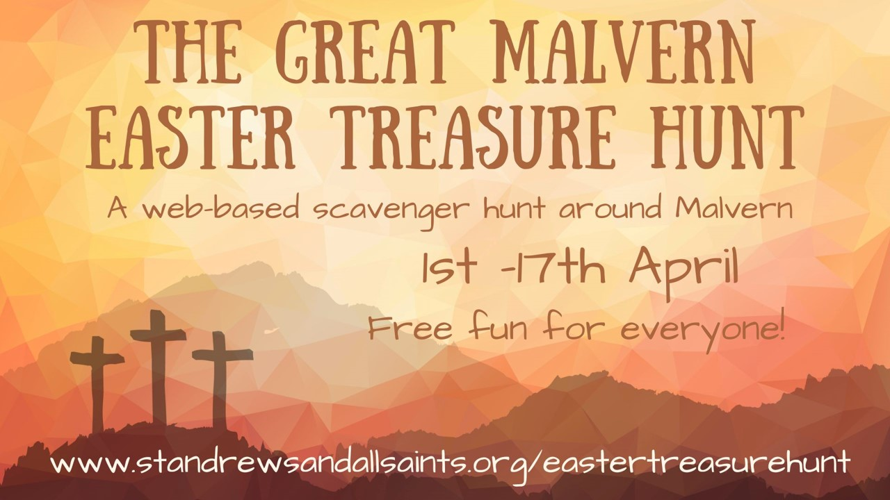
If you have trouble accessing the treasure hunt app you can follow the treasure hunt here and still watch all the videos:
- Start - St Andrew’s Church, Poolbrook (WR14 3JX)

Watch the welcome video here: https://youtu.be/zXc-ZCW-Ccw

Question 1: What time is the Early Birds Service on Easter day?

- Palm Sunday - Bus shelter at the top of Barnard’s Green (WR14 2QH)

Watch the Palm Sunday video here: https://youtu.be/Tf_ipX_Umeo
Question 1: What animal did Jesus ride into Jerusalem on?
Question 2: Which of the following did the crowds do that first Palm Sunday (there may be more than one right answer)?
- Shout Hosanna
- Wave Palm Branches
- Shout ‘crucify him’
- Lay their coats down before him
Enter into the story Question:
Rev Dave described in the video that Jesus entering into Jerusalem on a donkey was a bit like a famous person today driving into Malvern on an old bashed about motorbike. Imagine what that might be like as you look down the road in Barnard’s Green.
How do you think you would have felt if you had been there watching Jesus ride into Jerusalem that day?

- The Last Supper – Lyttelton Well (next to the Priory Church – WR14 2AY)

Watch the Last Supper video here: https://youtu.be/n5z8V2yH5rk

Question 1:
How many people in total were at the last Supper?
Question 2:
Jesus shared two things at that Last Supper which Christians still share at Holy Communion. Bread and what?
Enter into the Story Question:
Sit down for a few minutes at one of the tables outside the Lyttelton Well and imagine what it was like for the disciples to have their feet washed at the last supper.
Take a ‘selfie’ of one of you washing someone else’s feet. The more creative the photo the more chance you have of winning the prize!

- The Garden of Gethsemane - All Saints Church, Wells Road (WR14 4PA)

Watch the Garden of Gethsemane video here: https://youtu.be/qxHXOBQBbrk

Question 1:
What did Jesus ask the disciples to do in the garden? (one word)

Question 2:
What did the disciples actually do in the garden?

Enter into the story Question:
In the garden Jesus asked his disciples to pray for strength for him as he knew he was about to be arrested and die on a cross.
We too can pray for those who are in need, who need God’s help.

As you stand in the garden think of someone you know who is in a difficult situation at the moment. Maybe there are ill, lonely or bereaved. Pray for them now that God would help them.
You might like to tie a ribbon on the tree to remember them.

In the space below, write the name of the person you are praying for and St Andrew’s and All Saints will join you in praying for them too….

Now head on to British Camp Car park… remembering to stop at the Wells School on the way to pick up an extra mystery letter.

- The Trial - British Camp Car park (WR13 6DW)

Watch the trial video here: https://youtu.be/9-XvmyWV5Yo

Question 1:
Who was the Roman governor deciding whether Jesus was guilty or not?
- Herod
- Pontius Pilate
- Julius Caesar
- Augustus
Question 2:
What did the crowd shout when Pilate asked them what he should do with Jesus?
- Let him go free
- Crucify him
Enter into the Story Question:
When Jesus was on trial we are told that he remained silent and didn’t try and defend himself.
Why do you think that was?

- The walk to the cross - gate in the middle of British camp car park

Watch the walk to the cross video here: https://youtu.be/03BaYOBWuGc

Enter into the Story Question:
Now begin to walk to the top of British Camp, picking up a stone on the way to think of the sad things that you carry with you and the wrong things you have done in your life which you want to say sorry for.

How do you think Jesus felt on his walk to the cross and to his death to forgive you for these things?

- The Crucifixion – Top of British Camp Hill

Watch the Crucifixion video here: https://youtu.be/_4t6UhNvnkw

Question 1: How many other men were crucified alongside Jesus?

Question 2: Which of these were words of Jesus from the cross (there may be more than one correct answer)?
- Father forgive them for they know not what they do
- It is finished
- I’m hungry
- My God, My God why have you forsaken me?

Question 3: When Jesus died, the big heavy curtain in the temple was torn in two from top to bottom. What did this illustrate?
- The temple would be destroyed
- That the barrier between people and God had been taken away by his death
- That Jesus had lost
- That the chief priests would be punished for not believing in Jesus

Enter into the story Question:
There was a Roman soldier – a centurion – standing guard and watching Jesus’ death. When he saw all that had happened he was changed and he worshipped God and said ‘Surely this man was innocent.’
Having heard the story, what do you think Jesus death means to you?

Now leave the stone that you have been carrying behind as a reminder that Jesus’ death on the cross means you are forgiven and can be free… and head down South (away from the car park), to the top of the next little hill, before heading down the steep stone steps to the round stone signpost, and then follow the path right to Giant’s Cave…

- The Resurrection – Giant’s Cave

Watch the Resurrection video here: https://youtu.be/NKxW_17ig0Q

Question 1: What were the women who went to the tomb early that morning carrying with them?
- Flowers to put round the grave
- Spices to lay on Jesus’ body
- Linen to wrap Jesus’ body in
Question 2: Which of the following did they find when they arrived at the tomb (select all the correct answers)?
- Two angels
- The stone rolled away
- Jesus’ body was missing
- The grave clothes had been stolen too

Question 3:
When Mary first saw the resurrected Jesus, who did she think he was?
- A ghost
- The Gardner
- An angel
- One of the disciples

Enter into the story Question
Enter into the ‘tomb’ and think what it must have been like for those first women and disciples to find the tomb empty.
Pose for a photograph of your team at the ‘tomb’ showing you pretending to be the disciples/women when they arrived to find it empty.

Now head off back to the carpark and Sally’s cafe

- The Finish – Sally’s Café (British Camp Car park)
Watch the final video here: https://youtu.be/GxGiF90K7bQ

Now you should have all 9 mystery letters. Now rearrange them to reveal the hidden message (which is to do with the Easter story and is more than one word!).
Write it here…

We’d love your feedback.
Please tell us what you thought of the Great Malvern Easter Treasure Hunt here:

Prizes!!!
If you would like to be entered for the big prizes then please drop your answer sheet into the St Andrew’s church office and write your email here:

Do you want to explore this amazing story more?
If you’d like to explore more abotu this amazing story (children or adults) then we’d love to invite you to our Easter Services – you can find all about them here:
http://www.standrewsandallsaints.org/easter-2023/
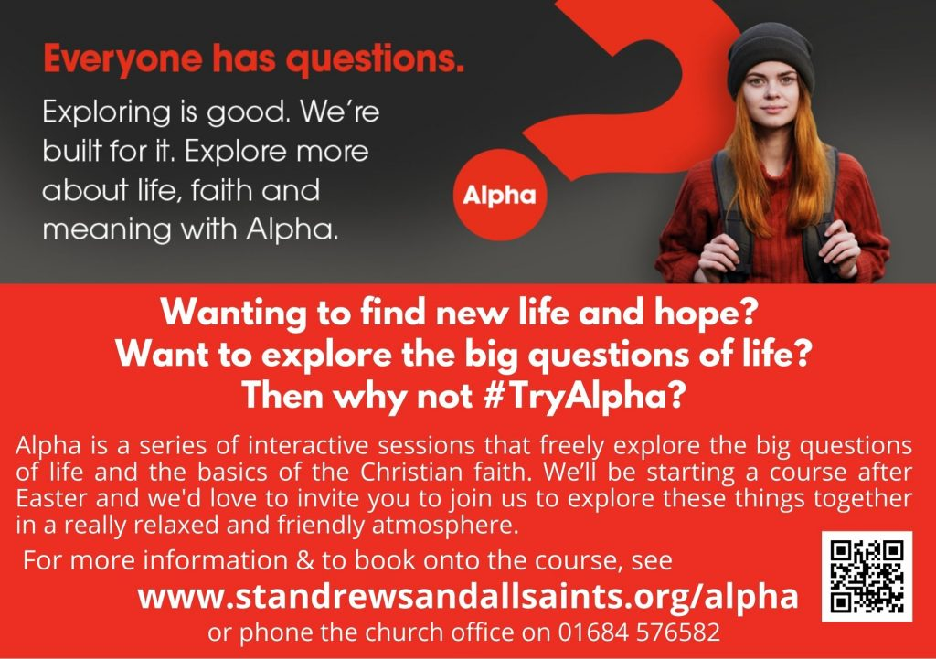
And we’ve also got an Alpha course starting after Easter which is a great course for people to come to explore this story and the big questions of life in a relaxed and informal setting. We’d love to invite you to join us. More details are here: http://www.standrewsandallsaints.org/ministries/alpha/
If you are interested in finding out more, do leave us your email here:

Now go and collect your prize….
Go to Sally’s Café and tell them the mystery message and they will give you your prizes!

Well done for completing the Great Malvern Easter Treasure Hunt!

