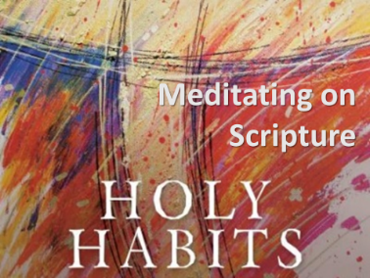
Holy Habits for the Whole of life:
Meditating on Scripture

“The goal is not for us to get through the Scriptures. The goal is to get the Scriptures through to us.”
(John Ortberg, The Life you’ve Always Wanted)

Method 1: Meditating on Scripture

1. Take time to ask God to meet you in scripture
2. Read the Bible in a repentant spirit with a readiness to obey and put into practice what it says.
3. Meditate on a fairly brief passage or narrative, reading it slowly several times if necessary.
4. Allow certain words or phrases to stand out and sink into your heart.
5. Prayerfully ask the question “God what do you want to say to me in this moment?”
‘Listen for a word that creates a present encounter’
(Rowan Williams)
6. Take one thought or verse with you to “chew on” throughout the day.
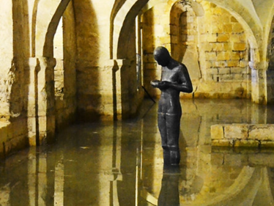

METHOD 2: Imaginative Contemplation
‘A method of prayerfully meditating on scripture where you let the Holy Spirit guide your imagination’
- Read the story slowly a couple of times
- Ask the Holy Spirit to guide your imagination
- Imagine yourself in the story…
- Imagine the sights, sounds, smells…

  - Who are you in the story?
  - Where do you find yourself in the story?
  - Imagine Jesus encountering you and interacting with you?
    - What does he say to you? What do you say to him?
    - How does he look at you?
    - How do you feel?
    - How do you respond?
  - What happens?
- Once you have come out of your reflection, play it back with God in prayer and ask Him how He wants you to respond and learn?
More resources on ‘Imaginative Contemplation’
You can find out more about ‘Imaginative Contemplation and Ignatian Spirituality here: https://www.ignatianspirituality.com/ignatian-prayer/the-spiritual-exercises/ignatian-contemplation-imaginative-prayer/

You can try some guided meditations here from the Pray as you Go app:
https://pray-as-you-go.org/series/5-imaginative-contemplation-exercises

Some scripture to meditate on: Mark 1: 14-20

Jesus Announces the Good News
¹⁴ After John was put in prison, Jesus went into Galilee, proclaiming the good news of God. ¹⁵ “The time has come,” he said. “The kingdom of God has come near. Repent and believe the good news!”

Jesus Calls His First Disciples
¹⁶ As Jesus walked beside the Sea of Galilee, he saw Simon and his brother Andrew casting a net into the lake, for they were fishermen. ¹⁷ “Come, follow me,” Jesus said, “and I will send you out to fish for people.” ¹⁸ At once they left their nets and followed him.
¹⁹ When he had gone a little farther, he saw James son of Zebedee and his brother John in a boat, preparing their nets. ²⁰ Without delay he called them, and they left their father Zebedee in the boat with the hired men and followed him.

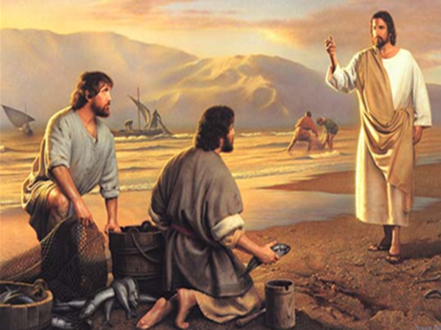

Passages to Meditate on during Lent:

Take some time each day to reflect on one of the following passages. Have a notebook with you to note down any reflections you have each day. At the end of Lent reflect back on what God has shown you and give thanks.

God’s unconditional love for me
1. Isaiah 43:1-7
2. Luke 12:22-34
3. Psalm 23
4. Psalm 131
5. Psalm 139:1-18
6. Luke 15:11-32
7. Luke 7:36-50

Learning how to pray
1. Luke 11:1-13
2. Isaiah 55:1-13
3. Psalm 63:1-8
4. Psalm 103
5. Romans 8:26-7
6. Ephesians 3:14-21
7. Psalm 62:1-8

God’s invitation to follow him
1. Mark 1:14-20
2. Luke 1:26-38
3. Mark 10:17-27
4. Philippians 3:7-16
5. John 3:22-30
6. Matthew 14:22-32
7. Matthew 25:31-41

God at work in your life
1. Jeremiah 18:1-9
2. Jeremiah 29:11-14
3. Romans 8:18-25
4. Ezekiel 36:25-27
5. Psalm 51:1-12
6. Galatians 5:16-26
7. Ephesians 2:4-10

The Events of Holy Week
1. Luke 22:39-46
2. John 19:1-6
3. Luke 22:26-43
4. Romans 5:1-11
5. Isaiah 53:1-6
6. John 3:16-17
7. John 20:11-18

