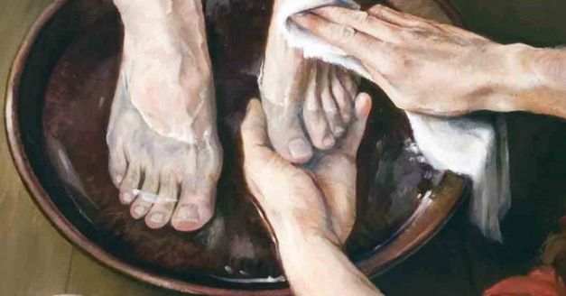
Maundy Thursday Experience

Welcome to our ‘Maundy Thursday Experience.’ The evening will run unprompted so do please read these instructions carefully when you arrive. We will be particulalry using videos of John 13-18 to reflect this year, and then gathering inside and outside to dwell with God in the story. Times will be approximate.

7pm ‘Footwashing.’ (John 13:1-17)
We begin this evening in the upper room, reflecting on Jesus washing the disciples feet. There will be an opportunity to wash each other’s feet if you wish.

As you do so, or watch on, reflect on the following:
- What must it have been like for the disciples to have their feet washed by Jesus?
- What do Jesus’ words ‘Now that I your Lord and teacher have washed your feet, you also should wash one another’s feet’

7:30pm ‘Sharing bread and wine’ (John 13:18 – 14:31)
We then dwell around the table at the Last Supper, listening to the conversations, and sharing communion together.

As you take the bread and wine, reflect on the following:
- What must Jesus have felt sharing the table with Judas who would betray him and Peter who would deny him? How did he respond?
- As you take the bread and wine, dwell once again in what Jesus went through that night for you.
- Dwell once more in those comforting words of Jesus ‘Peace I leave with you, my peace I give you. I do not give as the world gives. Do not let your hearts be troubled and do not be afraid’

7:55pm ‘Heading out to the Mount of Olives’ (John 15 & 16)
Jesus and his disciples then headed out to the Mount of Olives and the Garden of Gethsemane. As they did, Jesus continued to teach about the vine and the branches, the Holy Spirit and about what was ahead.

Either inside the church, our outside in the garden, take time to reflect on these words. Use some Lectio Divina techniques…
- What word or phrase in these chapters does God draw you to?
- Pray into that phrase and dwell in it. What does God want to say to you tonight?

8:20pm ‘Praying in the garden’ (John 17)
In the garden Jesus prayed these remarkable prayers… for himself….for his disciples… for all believers (that’s us!). Listen carefully to his prayers.

Either inside the church, our outside in the garden, take time to reflect on these remarkable prayers.
- How do you feel to know that Jesus was praying for you on that night before he died?
- Take some time to pray in the garden for people you know who are in need at this time. You might like to tie a ribbon on our prayer tree to represent your prayer for them.

8:40pm ‘The arrest and denials’ (John 18:1-27)
We watch Jesus being arrested, his disciples deserting him and Peter denying him.

After watching the video, head out to the fire in the courtyard and sit by it for a while.
- Where do you deny Jesus in your everyday life?
- What do you need to confess to God and allow him to forgive you and restore you?

You may like to write something on a piece of paper and then throw it in the fire as a sign of God’s forgiveness….

9pm ‘Jesus is sentenced to be crucified’ (John 18:28-40)

We finish with Jesus being sentenced to death. We dwell in what it must have been like for him. But we leave knowing this was not the end of the story….

