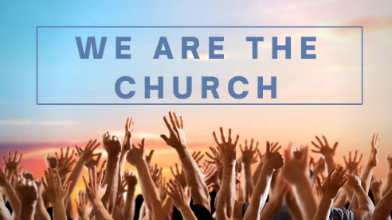
We are the Church
Session 7: Passing on the baton
Psalm 78:1-4; 2 Timothy 1:3-7

Opening discussion:
- Think back to when you became a Christian. When was it? Who helped you in your journey? How many of your life group came to faith when they were under 18?

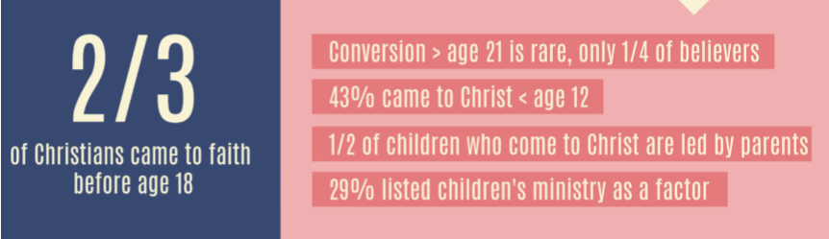

Passing on the baton to the next Generation
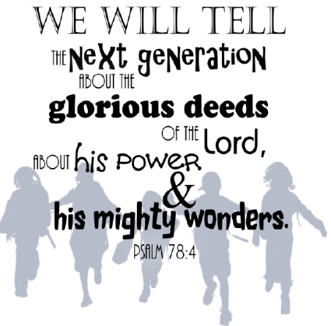
Read Psalm 78:1-4 and 2 Timothy 1:3-7

- What do these verses say about ‘passing on the baton’ and how God sees this?
- What did ‘passing the baton look like for Israel’ (Deuteronomy v7-9) [Note – this was written to the whole community, not just to parents]?
Deuteronomy 6:7-9 Message version:
Write these commandments that I’ve given you today on your hearts. Get them inside of you and then get them inside your children. Talk about them wherever you are, sitting at home or walking in the street; talk about them from the time you get up in the morning to when you fall into bed at night.
- What might it look like today? What might a 21st century description of v7-9 be?
- If you have children or grandchildren, how do you do this already? How could you do this more?
- Read 2 Timothy 1:6 and a 1 Timothy 4:12. Timothy was clearly quite young (and inexperienced?). What do you think it means to ‘fan into flame’ the gifts our young people have? How can those of us older help the younger generation be the ministers of today not just tomorrow?

‘It takes a whole church to raise a child’: What part can you play?
- What do you think about the above statement?
- What might it look like in practice?
- How have you seen this in action in our churches over the last year or more? What are you encouraged about?

How can you join in? How can we all play our part:
Here are some suggestions – and do talk to Helen, Liz or Dave if you want to offer support in these areas.

- Pray
Could you commit regularly to praying for our children and young people?
- Pray for their leaders involved with children and youth work
- Pray for the different ministries we are involved in – at church, in our schools, at the Octagon
- Pray for families in our church
- Join In… & Join Out.
Could you offer your time to help out in any of our ministries both within and outside of the church: Sunday work, Messy Church, Toddlers, Schools Work, Thursday project at the Octagon Youth, mentoring? There are lots of ways you can support and some are really practical (e.g. setting up the rooms, making cakes, serving refreshments coming and chatting to parents etc.)
Do speak to Helen to find out more.

- Growing Faith in Families
How might you make small steps to help grow faith in your families – with your children or grandchildren.
Some good ideas and resources here:
www.going4growth.com/growth_in_faith_and_worship/faith-in-the-home

- Walking alongside & encouraging our young people
What small step might you do this week to encourage a young person?
- Ask them what you can pray for them? And let them pray for you too!
- Find out what the challenges are for them to be a Christian at school and with friends
- Share some of your story with them and let them tell you theirs!

Pray now for your children, youth and families:

In the name of Jesus, we bless our Young People that they will grow and be filled to overflowing with your Spirit, and shine for you in their schools, with their friends and in their families.
Help them to learn what it means to walk with you. Amen.

