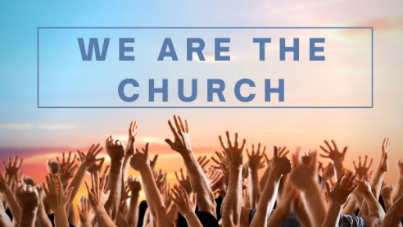
We are the Church
Session 6: A People of Prayer
2 Chronicles 7:11-14, Colossians 1:3-14

Share any stories you may have this week about how you have ‘been the church’ and lived out some of the things we’ve been reflecting on over the last few weeks.

What is prayer to you?
This week we are thinking about being a ‘people of prayer’ and being ‘rooted in prayer.’
- Think back over your prayers of the last week… what have your prayers been about?
- Read Colossians 1:3-14 – How do your prayers compare to the sorts of prayers Paul was praying for the church in Colossae? Is there anything you notice?

A call to humble ourselves and pray…
Read 2 Chronicles 7:11-14
- What is the context here- what has just happened (see v1-10)?
- God’s people kept being disobedient and not following God’s commands, and as a consequence they faced judgement (v13). But what does God tell them as a sign of his grace (v14)?
- What are the 4 things that the people are commanded to do in v14? What do you think they each mean?
- What are the 3 things God promises in v14 if they do this? What do you think they mean?
- How do you think these verses may apply to us? What might it look like for us to do the 4 things that it calls the people to do in v14?
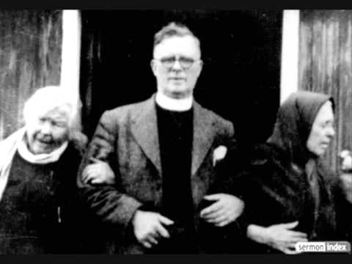
The Hebrides Revival
Dave in his sermon on Sunday talked about the Hebrides Revival (1949-1952) as a more recent example of this. You might like to listen together to Donald Campbell (the preacher who visited the Islands) share something of the story including how it started with two old housebound ladies praying – Listen to https://youtu.be/MXIZOSWvXaE (from 7:40 until 15:15). This was the start of the whole community flocking to the churches and encountering God.
- How do you see the promise of 2 Chronicles 7:14 played out in that revival?

‘If we really took Jesus’ invitation seriously, if we really believed in the sort of prayer that Jesus talked about, the modern church would have a hard time getting its people to do anything but pray!’ (Tyler Staton, ‘Praying like Monks, living like fools’ p98)

- Discuss this quote in the light of what you have already discussed.
- Why are we as a chruch and as individuals not as committed to prayer as we might be?

Praying ‘On Earth as it is in heaven’ prayers
In the Lord’s prayer we are particularly called to pray ‘Your Kingdom come, your will be done on earth as it is in heaven.’ Tylor Staton calls this praying ‘on earth as it is in heaven prayers.’ – praying that God would make this earth more like heaven…
- Think back to the prayers you prayed last week. How many of these were ‘on earth as it is in heaven prayers’?
- What might you pray for if you prayed ‘on earth as it is in heaven’ prayers for your family? Your community? Your workplace? Our nation?

Live it out…The call to prayer…
Take a few moments to sit in silence and allow God to speak to you about how he wants you to pray.

In 2017 St Andrew’s & All Saints was given a significant prophetic word from Rich Johnson the vicar of All Saints Worcester. Read this together and then pray that God would make us a ‘new kind of well’ from which would pour God’s life giving water into our communities.

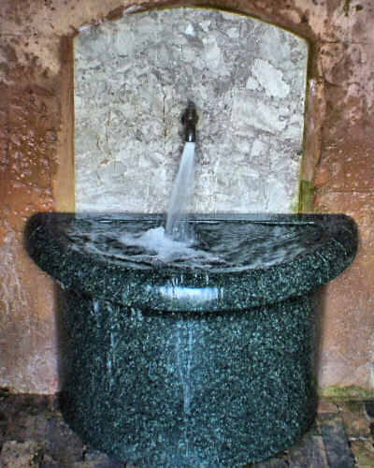
A new kind of Well
A prophetic word given by Rich Johnson 5th February 2017 at the Joint Service at St Andrew’s

“I don’t know much about the geography of the place but I know enough to know that Malvern is famous for its spa historically. And there are lots of wells aren’t there? And I just wonder whether God is calling this team of churches to become a ‘new kind of well’, or to rediscover in a deeper way what it is to be a well of the presence of God in this community - to be the kind of community in, and then through, which streams of living water flow. And for you to be confident afresh, that you offer out the water of life, that that is better than any other water – better that you can get from any other spa or any other well. And to trust that as you, as a community, press into the presence of God, and trust in the power of God, that through you, the presence of God will leak all around you; that people will experience what the woman at the well experienced, which is a kingdom that includes the excluded, that forgives the unforgivable, washes clean the dirty, and gives life to the hungry and the thirsty.
And I’m sure that is your heart, but I just sense that you are in a new season, that there has been a time of breakthrough, and as you have been doing this, God is saying some of these things to you now, and the question is simply this… ‘Will you let it be true for you first?’ Because if it is true for you, it will be true for everyone else. Because what is in you, wants out! So the more that is in you, the more that can go through you….”

Pray together…
We are creating two new opportunities to pray together each week (at least up until Easter). Would you join us and together we can ‘humble ourselves and pray and seek God’s face’ for our churches and our communities?

Monday Evening ZOOM prayers: Mondays 7:30pm-8:15pm
Tuesday morning ZOOM prayers: Tuesdays 7:30am -8:15am
Wednesday prayers at All Saints: Wednesdays 9am-9:30am
Friday prayers at St Andrew’s: Fridays 9am-9:45am
(see mailing for ZOOM codes).

