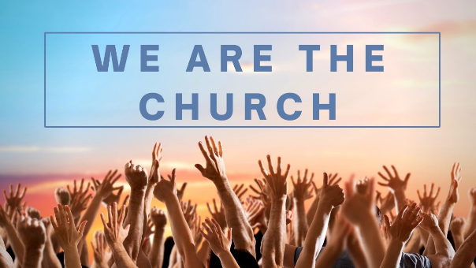

Church as a loving family

Introduction: Images of Church
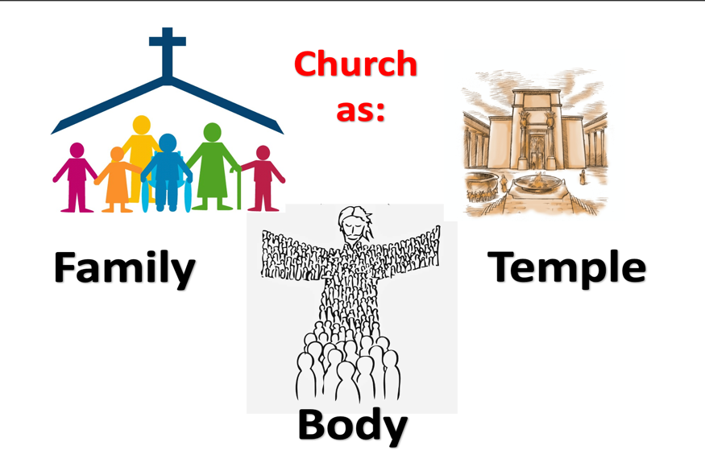
As we continue to consider what it means to be the church, we look today at one of the 3 great pictures of Church in the New Testament. They are:
Each of these images contributes something unique to our understanding of what it means to be church. Today we look at Church as Family.
The church is “the Family of God the Father, the Body of Jesus Christ His Son and the Temple or the dwelling place of the Holy Spirit.”
John Stott: God’s New Society

Each group member will need pencil and paper for this session.
Feel free to select, from the following, the questions that seem most relevant to your group.
Warm Up
On a sheet of paper quickly sketch your own personal family tree (go back 3 generations if you can) and share it in pairs.

Church as The Father’s Family

Romans 8:15-17

- How do we know we are members together of the Father’s Family?
- What is your understanding of the word “abba”?
- Jesus alone has the right to call God “abba father”, yet He encourages us to address God as “Our Father”. What implications does this have for us in our relationship with God and other Christians?
- No Jew would ever dream of addressing God as Father. Jesus put Himself at risk by doing so (see John 5:18). What does it mean to you to view God as your Father?
- What difficulties might some people have in thinking of their relationship with God and other Christians, in terms of family? How can we resolve these difficulties?
- How might belonging to God’s family impact our relationships with our own personal family members?
- What motivates God to make us His children? (1 John 3:1-2)

How people ought to conduct themselves in God’s Household / Family, which is the church of the living God. (I Timothy 3:15)

- What would it mean if we started to treat one another as we would the much-loved members of our own families?
- How does Paul tell Timothy to treat others in the church? (1 Timothy 5:1-2) How might this change the way we treat one another in our church family?
- If others in church are our brothers and sisters, how are we to do what John tells us in 1 John 3:16?
- We don’t always get on well with members of our own family. We don’t always get on well with our brothers and sisters in Christ. How can we resolve this?

Live it out… Being a member of the Father’s Family this week
As a final group exercise, take a moment to write down 3 things you need prayer for currently. Then swop your list for someone else’s. Take their list home and get praying each day for what they have written down. Then, when you meet next time, ask them: “How are those things now?”.
For further study:
“The theme of family relationships is particularly prominent in 1 Timothy” (Peter T O’Brien).
Take time to read through 1 Timothy and make notes on what it says about church family life.

