We are the Church
Session 2: Whole Life Disciples:
Jesus Followers
Mark 1:14-20, 3:13-15 & Hebrews 10:19-25

Reflect back on last week’s session about being ‘devoted worshippers’
- What has continued to stay with people?
- Have people done anything differently this week to seek to worship God throughout the week? How has it gone?

Being Whole-Life Disciples

“The greatest challenge the church faces today is to be authentic disciples of Jesus.”
(Dallas Willard)

- What does ‘being a disciple’ mean for you? Share briefly in 2’s and 3’s…

Read Mark 1:14-20 – the call to follow Jesus
- Dave talked in his sermon about the difference between ‘inviting Jesus into your life’ and Jesus’ invitation to the first disciples to ‘Come follow me [Jesus]’ (Mark 1:17) into His new life… What do you think the difference is between them? Which description best fits how you see your relationship with Jesus?

- Imagine you were one of the first disciples felt as they were called by Jesus to follow him. How would you have felt? In comparison, how do we feel about following Jesus today?

- Read Mark 3:14-15. How does it describe what Jesus called the first disciples for? We may not have the experience that those first disciples did of being with Jesus in the flesh, but how is our call to be a disciple similar?

Read Hebrews 10:24-25 – doing it in community

“True discipleship involves deep relationships. Jesus didn’t lead a weekly Bible study. He lived life with his disciples and taught through actions as well as words”
(Frances Chan)

- Jesus chose to do discipleship in community, choosing his ‘life group’ of 12 to invest in and ‘do life and mission’ with.
  - Why do you think he did it this way?
  - What about your life group most helps you grow as a Christian? Is there anything your life group could learn or do differently in the light of Jesus’ methods?

Back at the start of 2020 (remember that?) we came up with our church definition of discipleship, below, that Dave shared again on Sunday.

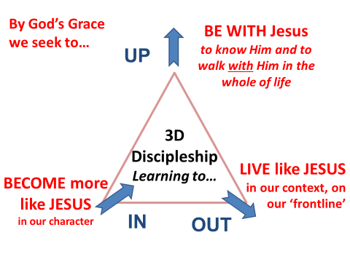

We’ll think more about the OUT next week, but for this week, take a few minutes in silence to reflect on the UP and the IN.
- How are you doing in these areas and particularly with your ‘rhythms’ of being with God?
- What are you finding helpful at the moment? What are you find challenging?

After a few minutes of reflection share with each other your responses and encourage each other. Then take time to pray for each other in response to what you have shared.

Pray together: Pray also for our ‘young disciples’ our children and young people and all those who journey with them in faith in our churches.

Live it out… Be a Jesus Follower this week…
The New Year is a great time to review our spiritual journeys. Take some time out to reflect on your own discipleship journey this week, and in the coming weeks. Here are some ideas:

Try something new: Discipleship Resources
We have lots of discipleship resources on our website which you might find useful.
See http://www.standrewsandallsaints.org/discipleship-resources/

These include different resources to help read the Bible and develop a pattern of prayer and how to review your day with God (Examen).

Discipleship Journey & Discipleship MOT
- Back in 2020 we also put together a ‘discipleship journey’ sheet which suggested possible next steps for people at different stages of faith. You can download it here:
www.standrewsandallsaints.org/wp-content/uploads/2020/01/Discipleship-Journey-St-Andrews-All-Saints.pdf
- We also put together a Discipleship MOT which you might like to try out and then request someone to review it with you. See www.standrewsandallsaints.org/resources/discipleship-mot/

Connect up:
- If you are not in a life group, why not connect up with one? Or find a prayer partner?
- Try going along to the ‘Waiting Room’ at All Saints (Wed 18th January 7-8pm at All Saints)

