We are the Church
Session 1: Devoted Worshippers

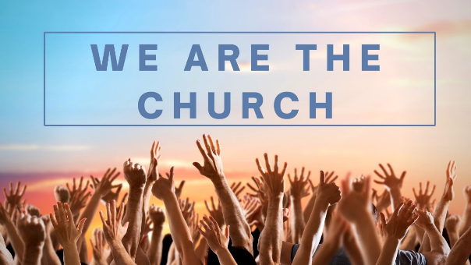
Introduction: What is church?
This series is to help us reflect and refocus on what church is all about and what we are called to be as members of God’s church. We’ll be looking at different aspects of church over the coming weeks (we’ll not be able to cover everything!), but to get people thinking here are a couple of discussions to open with…

- ‘I go to church’ or ‘We are the church’?
Which one of these statements do you most relate to? What is the difference between seeing church as something you ‘go to’ vs something you ‘are’?
- Church is… As a little opening exercise, in 2’s and 3’s come up with your own definition of ‘what church is’ in no more than 100 words.
Come back together as a large group and compare the different definitions you have come up.
What do you notice? What do you find interesting?
How close is it to a) what we are now and b) what the early church was?

Session 1: Devoted Worshippers
The first aspect we are looking at is our call to be ‘devoted worshippers.’

- What does worship mean to you?

Worship comes from the old English word ‘worth-ship’ meaning to attribute worth to someone or something, describing how worship is first and foremost about giving glory to God. The two main New Testament words used for worship are proskuneo meaning ‘to come towards to kiss’ and latreuo meaning ‘to serve or to minister.’
Read Matthew 2:1-11.
- We’re particularly thinking about the visit of the Magi this week as it is Epiphany. What do we learn about worship from the visit of the Magi to Jesus?

- Look up the following Bible passages. What do they tell us about worship? You might like to write comments down on post-it notes and collate them.
  - Psalm 100:2
  - Psalm 95:6-7
  - Job 1:20-21
  - 1 Chronicles 16:29
  - Hebrews 12:28
  - Romans 12:1-2
  - Revelation 4: 1-2, 6-11

- In the light of the above passages, how might you describe what worship is?

- Why do you think worship is important? You might like to reflect on the quotations below in thinking about this.

“Worship is what we were created for. This is the final end of all existence-the worship of God. God created the universe so that it would display the worth of His glory. And He created us so that we would see this glory and reflect it by knowing and loving it-with all our heart and soul and mind and strength. The church needs to build a common vision of what worship is and what she is gathering to do on Sunday morning and scattering to do on Monday morning.” - John Piper
“Worship changes the worshiper into the image of the One worshiped.” – Jack Hayford
- The quotations below link in with the reading from Romans 12:1-2. How can we ‘offer our bodies as living sacrifices’ as an act of worship in our daily lives?
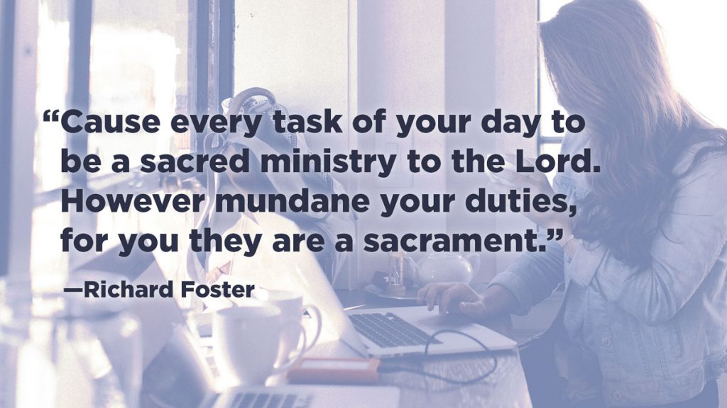
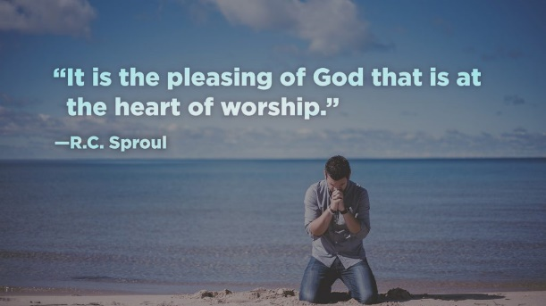
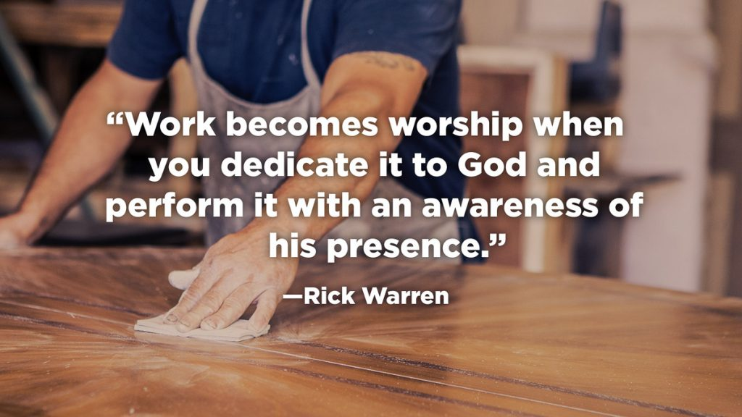
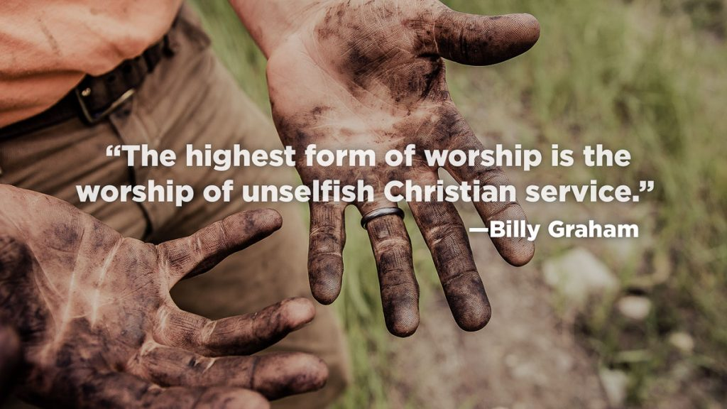
Take some time to worship…
In your group, take some time to worship God together.
You could do this in a variety of ways:

- Play some worship music e.g.
What a Beautiful Name https://www.youtube.com/watch?v=nQWFzMvCfLE
Waymaker https://www.youtube.com/watch?v=SE_M9noEhNE
- Speak out a Psalm together E.g. Psalm 100 and then offer prayers of worship and praise
- Reflecting on the names and attributes of God.

Live it out… Be a Devoted Worshipper this week…
Seek to be intentional this week about being a ‘devoted worshipper’. More than anything, pray that God will give you a heart of worship this week.

Here are some suggestions of other things you might try… but you might also take time in your group to share together ways in which you worship God in your Monday to Saturday lives.

- Set aside some time each morning to worship God by listening (and singing along!) to worship music. Let this lead you into praise of who God is.
- Each day take some time to focus on a different ‘name of God’ (For example use https://momsinprayer.org/wp-content/uploads/2021/01/pdfNamesOfGod2021.pdf ) and offer God your praise and worship for who He is.
- Take a few minutes each day to kneel before God in silence (Psalm 95:6) and offer your whole self to him in the quiet, surrendering the day to His service.
- Be intentional about dedicating your work and the mundane tasks of each day to God as an act of worship (Colossians 3:17). As you ‘work’, look for God’s presence and give thanks to Him and seek to glorify Him by doing your very best in all you do.
- Take some time to confess before God where you are worshipping other things in your life instead of him. Ask God to show you what it means to ‘worship him alone.’ How is he calling you to repent and live life differently?

And a final quote for those who are struggling to worship…

In The Unquenchable Worshipper, Coming Back to the Heart of Worship, Matt Redman observes: “So often when my worship has dried up, it’s because I haven’t been fuelling the fire. I haven’t set aside any time to soak myself under the showers of God’s revelation. Often, time is the key factor. But if we can find space to soak ourselves in God’s Word, his presence, his creation and spend time with other believers, then we’ll find that the revelation floods back into our lives; and our hearts will respond with a blaze of worship once more.

