Advent Waiting – Life Group Reflection Week 2
‘Waiting for Christ’s return’

During Advent we are going to be focussing on ‘waiting on God’ and reflect particularly on the verses that we will be using as a focus each week in our Advent Prayer, rather than the sermons topics. Over these sessions we encourage you not to spend too much time discussing and answering questions’ but to leave plenty of time of practising ‘waiting’ together and giving space for God to encounter us.

Opening Prayer

Holy Spirit of God, we wait for you.
Speak to us with your still small voice of calm.
Renew our strength,
restore our faith,
refresh our vision.
Help us to wait for you
through these weeks of Advent,
to make space,
to welcome the Word made flesh,
Jesus the child who is to come.
Amen.

Luke 12:35-40
- Read Luke 12:35-40 – Who is speaking in this passage? What is the parable about?

- What do you think it means to ‘Be dressed ready for service’? v35
As an individual? As a church?

- How can we keep our ‘lamps burning’? v35
As an individual? As a church?
- Read v40, why are we not told when Jesus will return? Would it be different if we knew when? How does not knowing effect our waiting?

Play / Sing / Read
You may wish to play or read aloud the words from this worship song:
https://youtu.be/N1DMIrqQVXI (Or scan the QR code to go straight there).

Oh Lord, You're Beautiful (Written by Keith Green)
Oh, Lord, You're beautiful
Your face is all I seek
For when Your eyes are on this child
Your grace abounds to me
Oh, Lord, You're beautiful
Your face is all I seek
For when Your eyes are on this child
Your grace abounds to me
I wanna to take Your word and shine it all around
But first help me to just to live it, Lord
And when I'm doing well
Help me to never seek a crown
For my reward is giving glory to You
Oh, Lord, please light the fire
That once burnt bright and clear
Replace the lamp of my first love
That burns with holy fear
I wanna take Your word
And shine it all around
But first, help me just to live it, Lord
And when I'm doing well
Help me to never seek a crown
For my reward is giving glory to You
Oh, Lord, You're beautiful
Your face is all I seek
For when Your eyes are on this child
Your grace abounds to me
Oh Lord, You're beautiful
Your face is all I seek
For when Your eyes are on...

Reflection:
We particularly encourage you to practise ‘waiting on God’ with no particular agenda other than encountering Him.
You might like to light a candle in the middle of the room as you reflect.
Have a time of silence to simply be in God’s presence. You may sense God speaking to you, you may not, but rest in his presence and simply ‘be’.
After a time of silence you might like to share any reflections together and pray for each other.
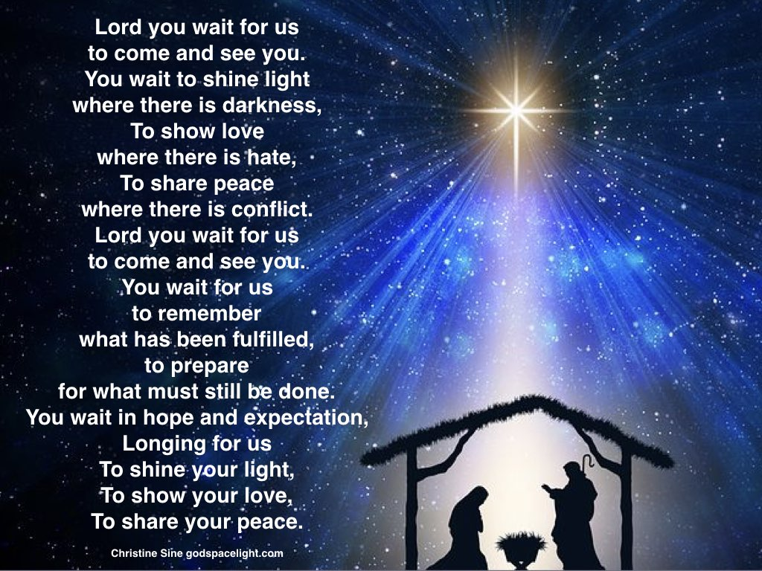

Final Advent Prayer
God of light, we await your coming again into our world.
Help us to share the spark of your love in this time as we wait.
May our faith and hope lead others to knowledge of your presence.
May we always live our lives in your love. Amen
Some Questions in our Waiting:
Father God, what do you want to do in me this Advent?
Father God, show me what you want me to pray for our church.
Show me where you are at work amongst us now?
Is there something you want to encourage us in?
Is there anything you want us to change? Or something new you are calling us too?
Who are you calling us to be and what are you calling us to be passionate about in this season?
How are you calling us to serve and be a blessing to our community (and other local churches) in this season?
Is there something you want to prepare us for?
Is there something you want to reveal to us about your character?

Life Group Leaders – please encourage members of your group to share anything they feel God is saying, either within the group or afterwards. Please then make sure that this is passed on to one of the Church Leadership Team.

