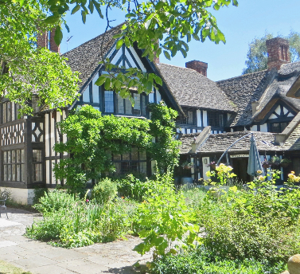

**Holland House Retreat and Conference Centre, Main Street, Cropthorne, Pershore, Worcestershire, WR10 3NB Telephone 01386 860330 Website: hollandhouse.org**

New dates for Holland House **‘Friendly lunches’**

These consist of a 2 course lunch, followed by an interesting ’after-dinner speaker’. All for £20.

The dates arranged so far are:

* **CANCELLED**Monday 1st August “Growing up in the Manse” by Liz Ross. To be re-arranged.
* **Friday 19th August – “Herbert Austin and the Longbridge story”**– **Max Hunt**, arranged in conjunction with Evesham Festival of Words.
* **Friday 23rd September  “Small churches are important” – Alison Maddox,**CE Dean of small churches, who lives locally
* **4th Nov.“ Canal People”by Tony Conder**in association with Evesham Festival of Words

**Quiet Garden Days**:

£18, including refreshments and a ‘picnic style’ lunch. They consist of a short reflection on a theme, which this year is ‘The Senses’, an optional Communion service at 12.15 (before lunch), and a shared group reflection to end, before tea. Plenty of time for personal reflection and to enjoy the gardens in the morning and afternoon. 10.30 am - 4pm.

The remaining dates for this year are:

* **Thursday 21st July - Revd Ruth Wintle (‘Touch’)**
* **Thursday 18th August - Revd Brenda Morton (‘Hearing’)**
* **Thursday 15th September - Revd Nicola Moon ‘(Smell)**

*For further details of these events, and to see other events arranged by Holland House, such as Garden Volunteer days, Day Retreats and longer ones – please see the website for details. Bookings can be made via the website or by phone.*